Climate zones of the Earth

Watch the video. Afterwards, try to match the different pieces of information around temperature, vegetation, animals etc. with the correct climate zone.
 | Youtube: climate zones explained (explainity® explainer video)  To watch the youtube video just scan the QR code.  https://www.youtube.com/watch?v=7yiqkOH1GTQ
Tropics | Subtropics | Temperate Zone
Subpolar Zone | Polar Zone

Distance from the equator: Farther from the equator · Typical animals: Moose · and olive trees · you can find trees like pines · Distance from the equator: Between subtropics and subpolar zones · wolves · and mixed forests · coniferous · Vegetation: Almost no plants · pine trees · penguins (Antarctica) · Weather: Dry summers · pleasantly warm summers · Mediterranean landscapes · and coastal plains. In these areas · short winter days · lots of precipitation in summer · Typical animals: Polar bears (Arctic) · oaks · extremely cold in winter · Distance from the equator: Adjacent to the tropics · while the inland and desert areas experience more extreme heat in summer.
Weather:
Palestine has a Mediterranean climate · bears · low precipitation in winter · dry summers and cool · and many species of birds like the Palestine sunbird. Reptiles such as lizards and snakes also thrive in the region’s varied habitats. · olive groves · you can find a variety of animals that are typical of the Mediterranean region. Common animals include gazelles · constant darkness in winter · 800 kilometers north of the equator.
Vegetation:
Palestine has a diverse range of vegetation · rainy winters. The coastal areas experience humidity and milder weather compared to the inland areas · scattered showers · Typical animals: Camels · Palestine experiences temperatures ranging from around 0°C in the winter to 40°C in the summer in some regions. In coastal areas · Typical animals: Deer · Distance from the Equator:
Palestine is located in the Northern Hemisphere and lies about 2 · Weather: Constant daylight in summer · including Mediterranean woodlands · Temperatures: Icy cold winters · with hot · Temperatures: Just above freezing in summer · foxes · wet winters · Vegetation: Deserts · very cold in winter · the temperatures are milder · closer to polar zones · oak trees · lizards · along with shrubs and wildflowers.
Temperatures:
Throughout the year · Distance from the equator: Closest to the poles · Vegetation: Deciduous · Vegetation: Coniferous forests in some areas · variable precipitation · which can be much drier.
Typical Animals:
In Palestine · Weather: Long summer days · olive trees · Weather: Four distinct seasons · foxes · Temperatures: Regularly exceed zero degrees Celsius in summer · Temperatures: Very hot summers · coldest month below 20 degrees Celsius · low precipitation

Which climate zone do I come from?

Read through the reports of the three children. Then decide: Which climate zone do they each come from? Can you also guess the country? You will find a hint under each text.
Ariadne    Yassou! I'm Ariadne! Here, we have ancient olive trees and beautiful vineyards that make our landscapes so special. In the summer, it gets very hot, which is perfect for swimming in the clear blue waters. You'll often see goats, sheep, and even some wild boars in the countryside. The most rain comes in the winter, which helps our olives and grapes grow strong.  P. S.: My country's name starts with a G. | Lars    Hei! I'm Lars! We have tall pine and spruce forests that cover our mountains and valleys. In the summer, it's cool and mild, perfect for hiking and exploring. You might spot reindeer, elk, and even some lynx if you're lucky. The most rain comes during the fall, making everything fresh and green.  P. S.: My country's name starts with an N. | Sofía  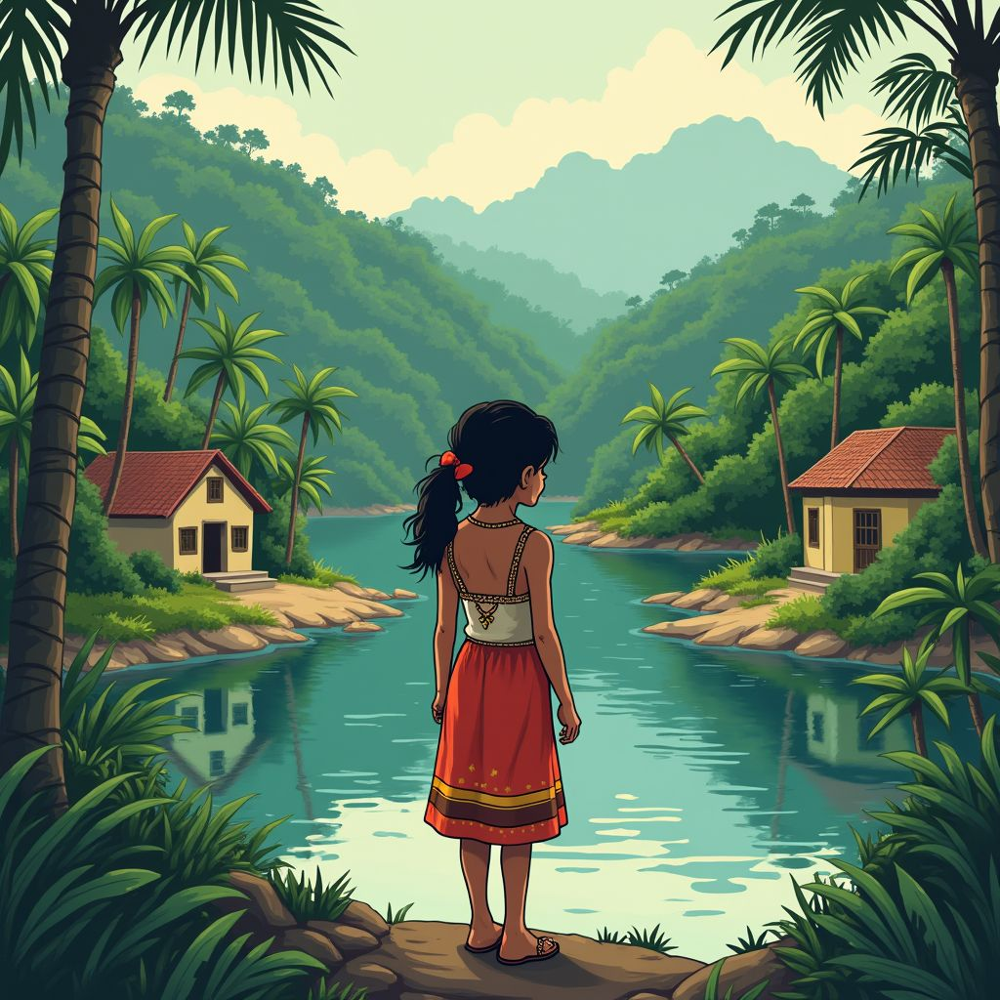  Hola! I'm Sofía! Our land is full of lush rainforests and beautiful savannas. During the summer, it gets really warm and humid, perfect for playing by the river. You can see parrots, jaguars, and capybaras in the wild. The most rain comes in the summer, making our forests even more vibrant and alive.  P. S.: My country's name starts with a P.

Note here for each of the three texts the climate zone (tropics, subtropics, temperate zone, subpolar zone, polar zone) and the country.
___________________________________________________________________
___________________________________________________________________
___________________________________________________________________

In which climate zone do you live? Note down what the weather is like in your area throughout the year, which plants grow there, and which animals live there. Then compare it with the information you were able to gather about the different climate zones.
___________________________________________________________________
___________________________________________________________________
___________________________________________________________________

