Moles

Moles are small animals that live underground. They have soft fur, small eyes and ears, and big paws for digging. Moles are found in many parts of North America, Europe, and Asia. Although some people don't like moles in their gardens, they actually help the soil and other animals by eating insects and worms.

Some interesting things about moles:

Moles can breathe underground even when there isn't much oxygen

They have an extra thumb on their front paws that helps them dig

Moles eat mostly earthworms and can store them alive to eat later

Baby moles are born in the spring and leave their mother after about a month

Moles are mostly solitary animals, but males will look for females to mate with. They do not like to share their territory with other moles and can be very aggressive towards each other.

In summary, moles are small animals that live underground, eat insects and worms, and have some interesting adaptations to help them survive in their environment.

My Notes
My Notes

___________________________________________________________________

___________________________________________________________________

___________________________________________________________________

___________________________________________________________________

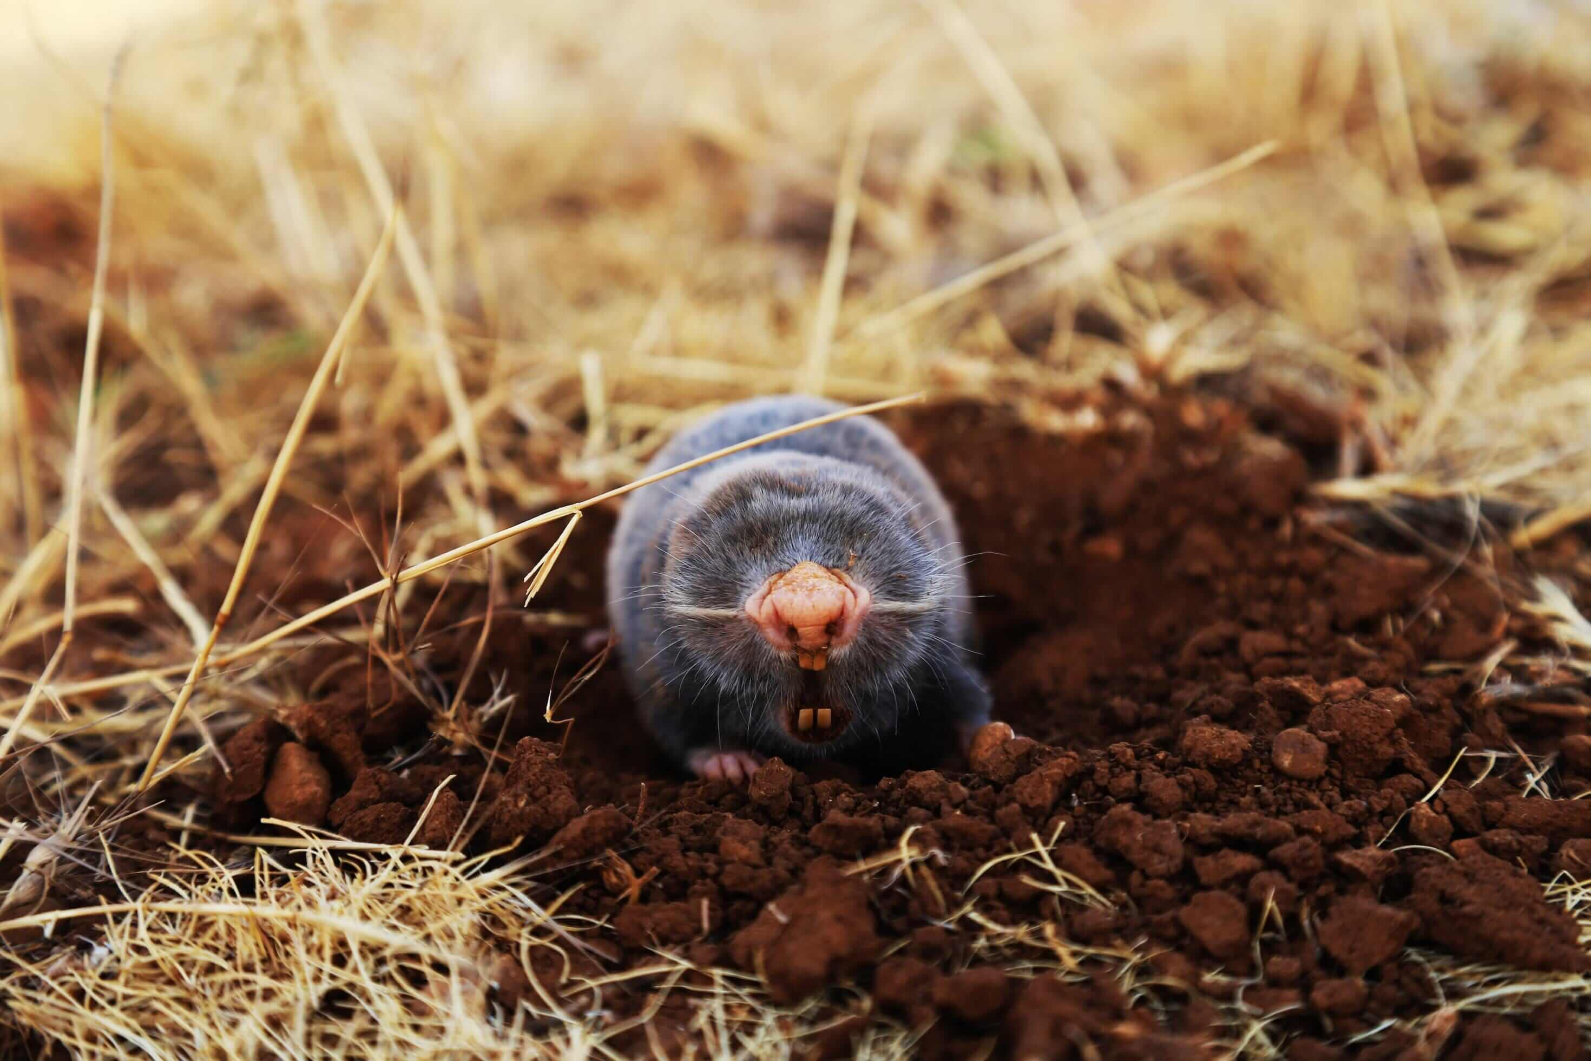 | Name
 | Height
 | Weight
Appearance

Habitat

Diet

Special features

Select the correct answer from the options provided.

Where do moles usually live?
Underground In trees In water In nests

What do moles mainly eat?
Earthworms Fruits Grass Leaves

Why do moles have big paws?
To help them dig To swim faster To climb trees To fly

When are baby moles born?
In the spring In the summer In the autumn In the winter

