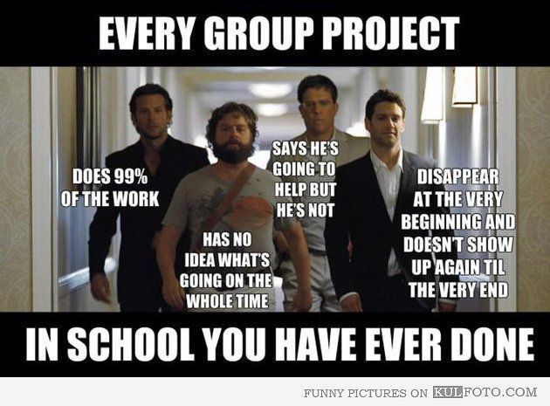

What's happening in the meme?
___________________________________________________________________
___________________________________________________________________
___________________________________________________________________
What does the meme tell us about school?
___________________________________________________________________
___________________________________________________________________
___________________________________________________________________

