|  |
| --- |
| Time capsule - a journey into the past Have you ever wondered what it would be like to travel back in time or what people in the future will want to know about us? With a time capsule, you can do just that!    time capsule  A is a container in which you store objects from the present day in order to find them again in the future. This allows people many years from now to experience how we live today.    Westinghouse time capsule  A famous example is the , which was buried for the 1939 World's Fair in New York. It contains everyday objects such as a pair of sunglasses, a toy doll and seeds to show the people of the future how we live.    first time capsule  1876  Thewas created in to celebrate the 100th anniversary of the USA. It contained books, newspapers, photos and even a telephone system!    Would you like to create a time capsule yourself? Here's how:    Choose a container  that is durable and waterproof.  Collect objects  that represent your life and the present day. For example, photos, letters, toys or a newspaper.  Pack the items securely  so that they are not damaged.  Label the time capsule  so that people know when to open it.  Bury or hide the capsule  in a safe place.  Make a note of the location and date  so that you or someone else can find it later.    message to the future  With a time capsule, you can send a. It's exciting to think about what people will think about us many years from now. So why don't you give it a try and create your own time capsule? |

### 📋 Put the actions in the right order.

|  |  |
| --- | --- |
|  | Label the time capsule with the intended opening date and any necessary information. |
|  | Bury or store the time capsule in a safe and memorable location. |
|  | Carefully pack the chosen items into the container, ensuring they are well-protected. |
|  | Write a note or include instructions to explain the significance of the items to future finders. |
|  | Seal the container securely to prevent moisture and air from entering. |
|  | Select items that represent your life and the present day, such as photos, letters, or newspapers. |
|  | Decide to create a time capsule to preserve memories for the future. |
|  | Choose a durable and waterproof container to protect the contents over time. |
|  | Record the location and details about the time capsule so it can be found in the future. |

### 📋 Work order

Before you look at the time capsule, read the story to get an insight into the era.

My name is William, and I am 11 years old. I live in the city of Florence in Italy. Our streets are busy with people selling goods and artists making beautiful things. My father is a painter, and I help him mix colors for his paintings.

People talk about a man named Leonardo da Vinci. They say he is a great artist and inventor. Last year, in 1502, he started painting a picture called the Mona Lisa. Everyone is excited to see it when it's done. I hope to be as good an artist as him someday.

Our city is full of amazing buildings. There's a big dome on the cathedral, built by Brunelleschi. It was finished before I was born, in 1436, but it's still the tallest thing I've ever seen. The buildings here are made in a new way called Renaissance style. They have lots of columns and arches, like in the old Roman times.

There are new inventions too. Not long ago, in 1450, Johannes Gutenberg invented a printing press with movable type. Now, books can be made faster and more people can read them. Father says knowledge is spreading everywhere.

Life here is full of music and art. Festivals happen often, with people dancing and singing in the streets. Traders come from faraway places, bringing spices and stories. They talk about Christopher Columbus, who sailed across the ocean in 1492 and found new lands.

If I could hide some things in a secret box for someone to find later, I would put in one of Father's small paintings, a printed page from a book, and a coin with the image of our city. Maybe someone in the future will find them and learn about our lives in this year of 1503.

### 📋 Choose the correct answer for each question.

###### **Based on William's description, how does the architecture in Florence reflect the influence of the Renaissance?**

The buildings are decorated with Gothic spires reaching towards the heavens. The buildings are made underground to conserve space in the city. The structures are primarily made of wood with simple designs. They are constructed with columns and arches reminiscent of ancient Roman times.

###### **Why is Johannes Gutenberg's invention significant in William's time?**

It created new types of paints for artists like William's father. It introduced mechanical looms for weaving fabrics. It helped sailors navigate to new lands by improving maps. It allowed for faster production of books, spreading knowledge more widely.

###### **What inspires William to aspire to be like Leonardo da Vinci?**

Leonardo's reputation as a great artist and inventor. Leonardo's success as a merchant bringing exotic spices. Leonardo's discovery of the printing press. Leonardo's role in constructing the cathedral's dome.

###### **Which items does William wish to hide in a secret box, and what does this reveal about his values?**

A map of new lands and a ship model, showing his interest in exploration. One of his father's paintings, a printed page, and a city coin, reflecting the importance of art, knowledge, and civic pride. A sketch of Leonardo's inventions and a piece of sculpture, indicating a focus on engineering. A musical instrument and festival banner, highlighting the city's love for celebrations.

###### **How do the innovations and events mentioned by William illustrate the broader changes during the Renaissance?**

They highlight a transition towards isolationism and reduced trade. They demonstrate a flourishing of art, exploration, and dissemination of knowledge. They show a decline in urban development due to economic hardship. They indicate a shift from artistic pursuits to agricultural focus.

## 📋Work order

The author of the text, William, filled this time capsule to tell about his life at that time. Look at the objects and think about whether you would fill the capsule in a similar or different way. What do you recognize from the stories?

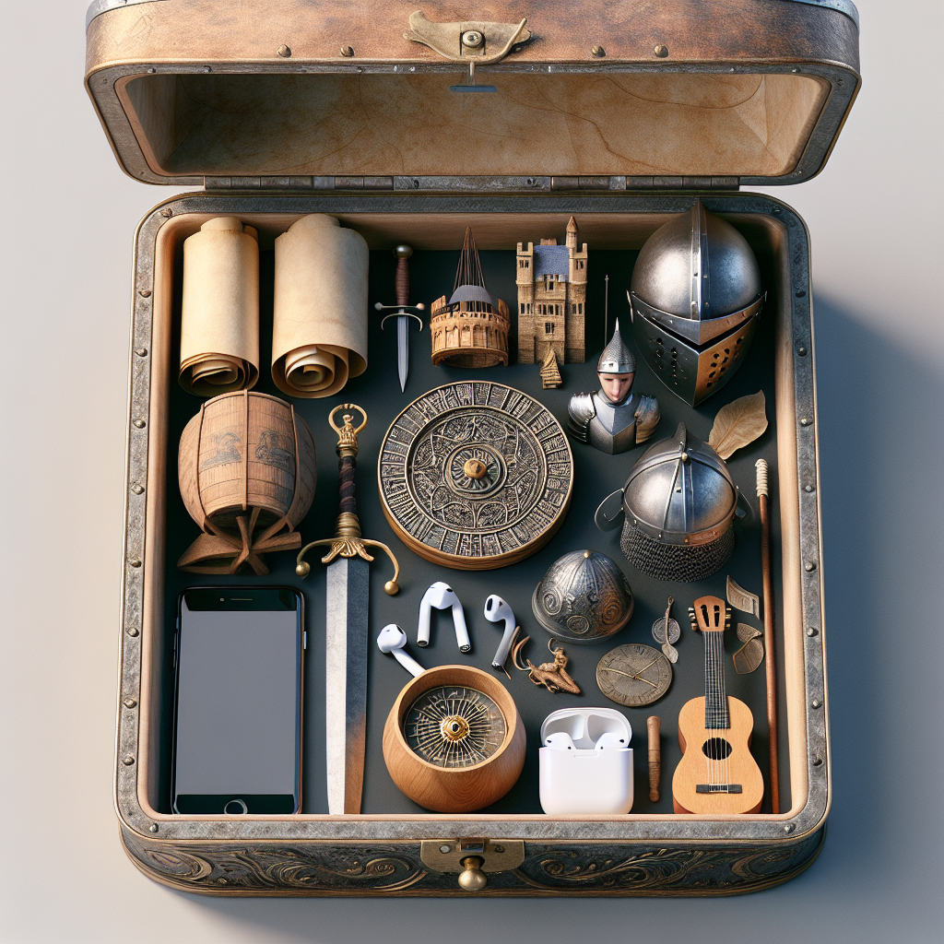

### 📋 Work order

So now it's your turn! Draw everything you would like to pass on to the next generation in the time capsule below.

