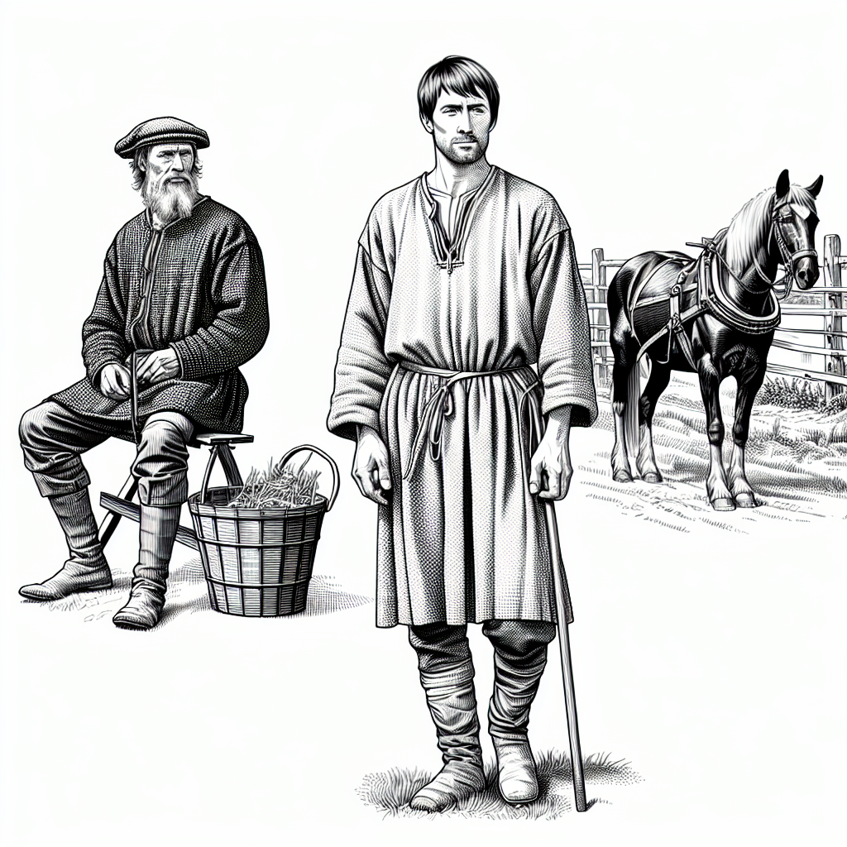

### 📋 Assignment

Read the following text and then answer the questions.

# A Day in the Life of Thomas the Farmer

Greetings! My name is Thomas, and I am a farmer living in the year 1200. At the age of 30, I am one of the older members of my village, as many of us do not live past 45 due to the many hardships we face.

My main task is to work the land for our lord, cultivating vital crops such as wheat, barley, and oats. Farming is all I've ever known, and it can be quite demanding. Each day, I rise before the sun with my family to tend to our fields. We plow the soil, plant seeds, and care for our animals, which include sheep, pigs, and a couple of oxen for plowing. Every season brings new challenges, from planting in the spring to harvesting in the fall.

Life in our village is simple but centered around community. We live in small houses made of wood and straw. Our social life revolves around the church, where we gather for mass on Sundays, share news, and enjoy each other's company. Festivals are special times filled with music, dancing, and feasting, offering a brief escape from our daily toil.

Though we are peasants, our work is essential. The food we grow sustains many people, including the lord and his household. Without our efforts, there would be no bread or ale. Sometimes, I wish we could keep more of our harvest, but the lord takes his share as part of our feudal obligations.

Everyday life can be tough. We face unpredictable weather, sickness, and the threat of bandits. Medicine is limited, and many fall ill. However, we support one another through these hardships. Our families are close-knit, and neighbors always lend a helping hand when needed.

Despite the difficulties, I find joy in the simple things. Watching our crops grow, hearing my children laugh, and knowing that I provide for my family gives me strength. I hope that life will be better for my children someday.

In our small way, we contribute significantly to the world. Farmers like me are the backbone of our society. Without us, there would be no kingdom, no lords, and no knights. We are the foundation upon which everything else is built.

### 📋 Choose the correct answer.

###### **Why is William considered middle-aged at 28 in his village?**

Because people are considered adults at age 15. Because education ends at age 28. Because 28 is the average age of farmers. Because life expectancy is low due to illnesses and hardships.

###### **What significance do Sundays hold for William and his community?**

Opportunities to gather at church for mass and socializing. They are days dedicated to paying taxes to the lord. Time for rest and recovery from weekly labor. Market days to sell their farm produce.

###### **How does William perceive the importance of his work as a farmer?**

He sees it as a burden imposed by the lord. He believes his labor is essential in feeding the village and kingdom. He thinks farming is outdated in the rapidly modernizing society. He feels it is unappreciated and wants to change professions.

###### **What are some everyday challenges faced by William and his family?**

Difficulty in finding land to cultivate. Dealing with competition from industrial farm machinery. Overabundance of food leading to waste. Scarcity of possessions and repairing rather than buying new items.

###### **Which statement best reflects the impact of diseases in William's time?**

Diseases are uncommon due to healthy living. Doctors are available and remedies are effective. Many do not survive infancy due to lack of medical access. Children rarely fall ill due to good healthcare.

### 📋 Work order

Fill in the profile using the information from the text.

|  |  |
| --- | --- |
|  | Name |
| Occupation |
| Life expectancy |
| social life | |
| Everyday life | |
| Influence | |
| Challenges | |

|  |
| --- |
| 📌 Info Here you will find the solutions for the teacher. |

|  |  |
| --- | --- |
|  | Name  Thomas |
| Occupation  Farmer |
| Life expectancy  Many do not live past 45 years due to hardships |
| Social life  Centered around the church, mass on Sundays, sharing news, festivals with music, dancing, and feasting | |
| Everyday life  Demanding work on the land, rising before sunrise, plowing, planting, caring for animals, facing unpredictable weather, sickness, and threat of bandits | |
| Influence  Essential work for the lord and his household; providing food for many people, forming the foundation of society | |
| Challenges  Unpredictable weather, sickness, limited medicine, threat of bandits, fulfilling feudal obligations | |