Mammals

Mammals are one of the most interesting groups of animals you can learn about. They are found all over the world and have some very special traits. Let’s explore their important features, body structure, and how they reproduce and grow!

Important Features

Mammals are warm-blooded animals. This means they can make their own body heat and stay warm even when it’s cold outside. So, you can see mammals like cats and dogs being active in winter without getting too cold.

One of the coolest features of mammals is that they have hair or fur on their bodies. This fur keeps them warm and sometimes helps them blend in with their surroundings. Think about lions with their majestic manes or polar bears with their thick white fur.

Another special thing about mammals is that they feed their babies with milk. The mothers have special glands called mammary glands that produce milk. This milk helps the baby mammals grow strong and healthy.

Body Structure

Mammals have some neat body parts that make them unique. They are vertebrates, which means they have backbones just like us. Their bodies are covered in hair or fur, which can be of different lengths and thicknesses.

Most mammals have four legs, but some, like whales and bats, have flippers or wings instead. Their legs are strong and help them run, jump, or swim. For example, kangaroos use their powerful legs to hop around, while dolphins use their flippers to glide through water.

Mammals have lungs to breathe air. This is why even sea mammals like whales and dolphins need to come to the surface to breathe. They also have different kinds of teeth. Some have sharp teeth for eating meat, while others have flat teeth for grinding plants.

Reproduction and Development

Mammals have a special way of having babies. Most mammals give birth to live young. The mother carries the baby inside her body until it is ready to be born. This is different from birds and reptiles that usually lay eggs.

After the baby mammal is born, it drinks milk from its mother. This helps the baby grow and stay healthy. As the baby grows older, it starts eating other food and learns how to find food on its own.

Mammals take care of their babies for a long time. For example, humans take care of their babies for many years, teaching them how to walk, talk, and do many other things.

In conclusion, mammals are fascinating creatures with their warm bodies, furry coats, and amazing ways of taking care of their babies. Next time you see a dog, a cat, or even a squirrel, remember how special these mammals are!

Notes
Room for your notes.

___________________________________________________________________

___________________________________________________________________

___________________________________________________________________

___________________________________________________________________
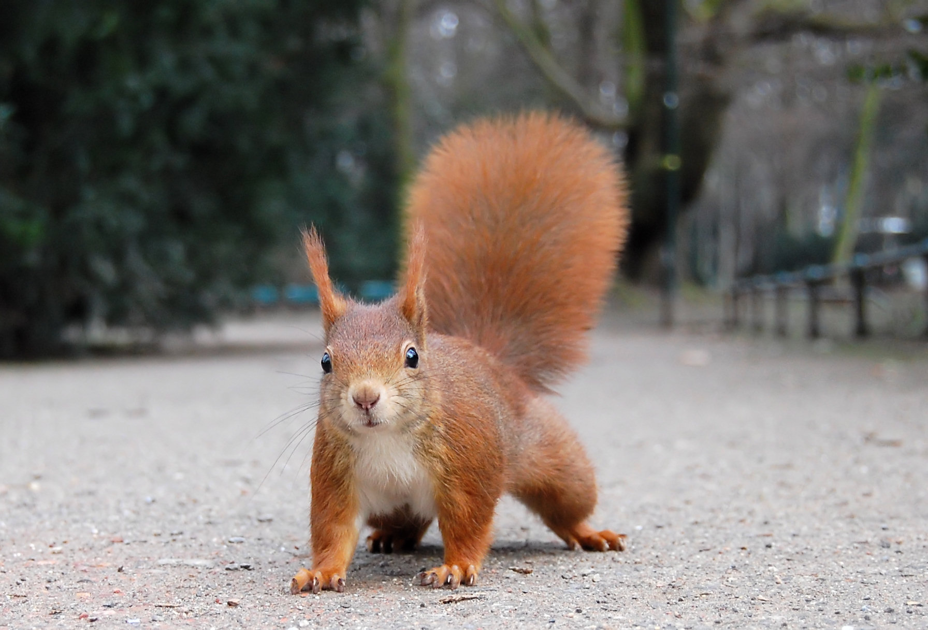 | Class of vertebrates  Mammals
Body temperature
Mammals are warm-blooded and can make their own body heat.
Body covering
Mammals have hair or fur on their bodies.
Respiration
Mammals breathe air using lungs.
Reproduction
Mammals give birth to live young and mothers feed their babies with milk from mammary glands.

Class of vertebrates

Body temperature

Body covering

Respiration

Reproduction

Answer the following questions:

Name three special traits of mammals.
___________________________________________________________________
___________________________________________________________________
___________________________________________________________________
Describe the body structure of mammals.
___________________________________________________________________
___________________________________________________________________
___________________________________________________________________
Explain how mammals reproduce and take care of their young.
___________________________________________________________________
___________________________________________________________________
___________________________________________________________________

Match the pictures to the right animal.
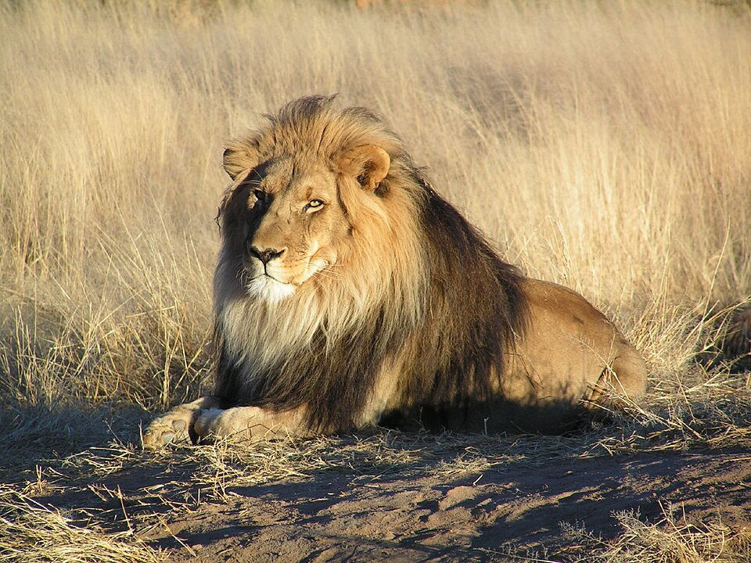 |  | tiger
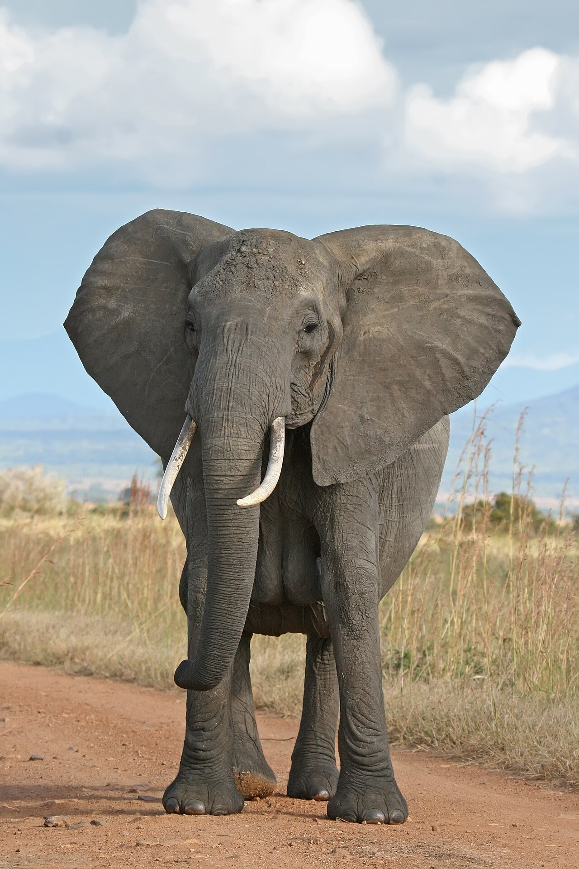 |  | lion
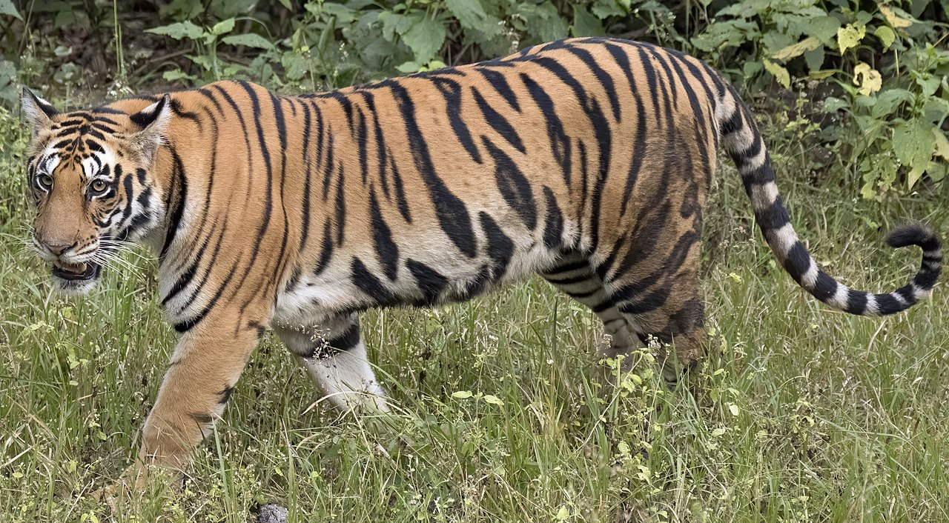 |  | giraffe
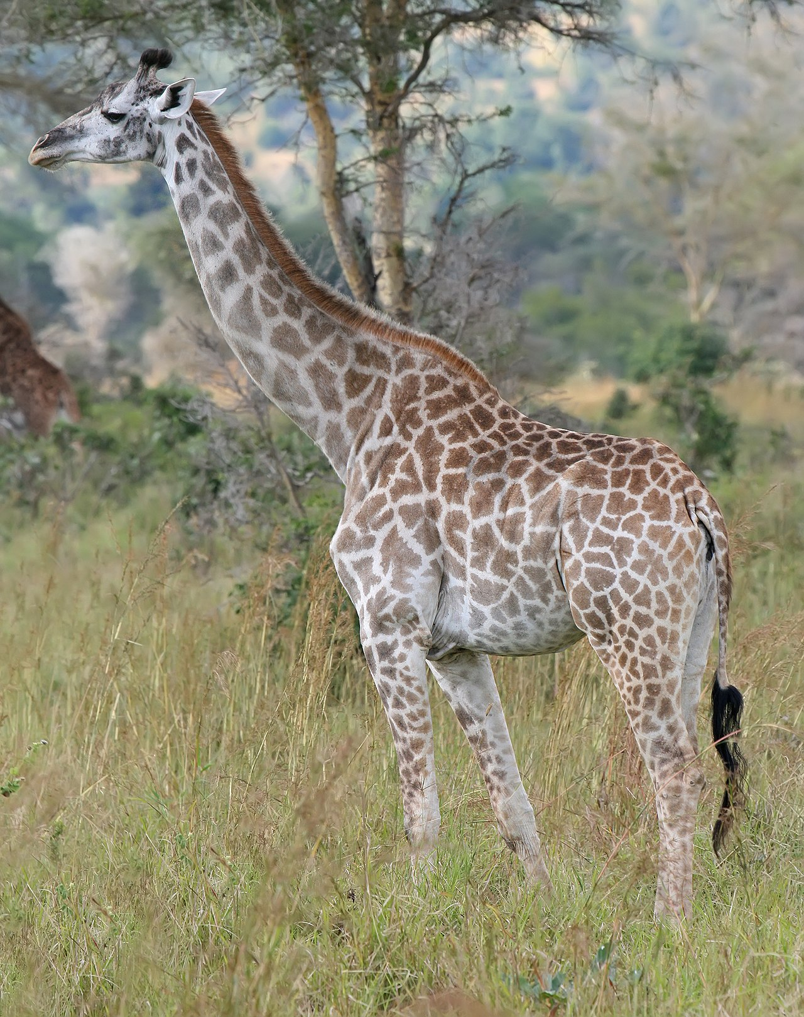 |  | elephant
 |  | dolphin

