## 5G Networks: The Invisible Threat to Our Health

23.10.2023

In a groundbreaking revelation, scientists have confirmed that the 5G mobile networks, introduced globally in 2019, are causing severe health issues. Researchers at the International Institute of Health have linked the high-frequency waves from 5G technology to a range of ailments, including insomnia, headaches, and even cancer.

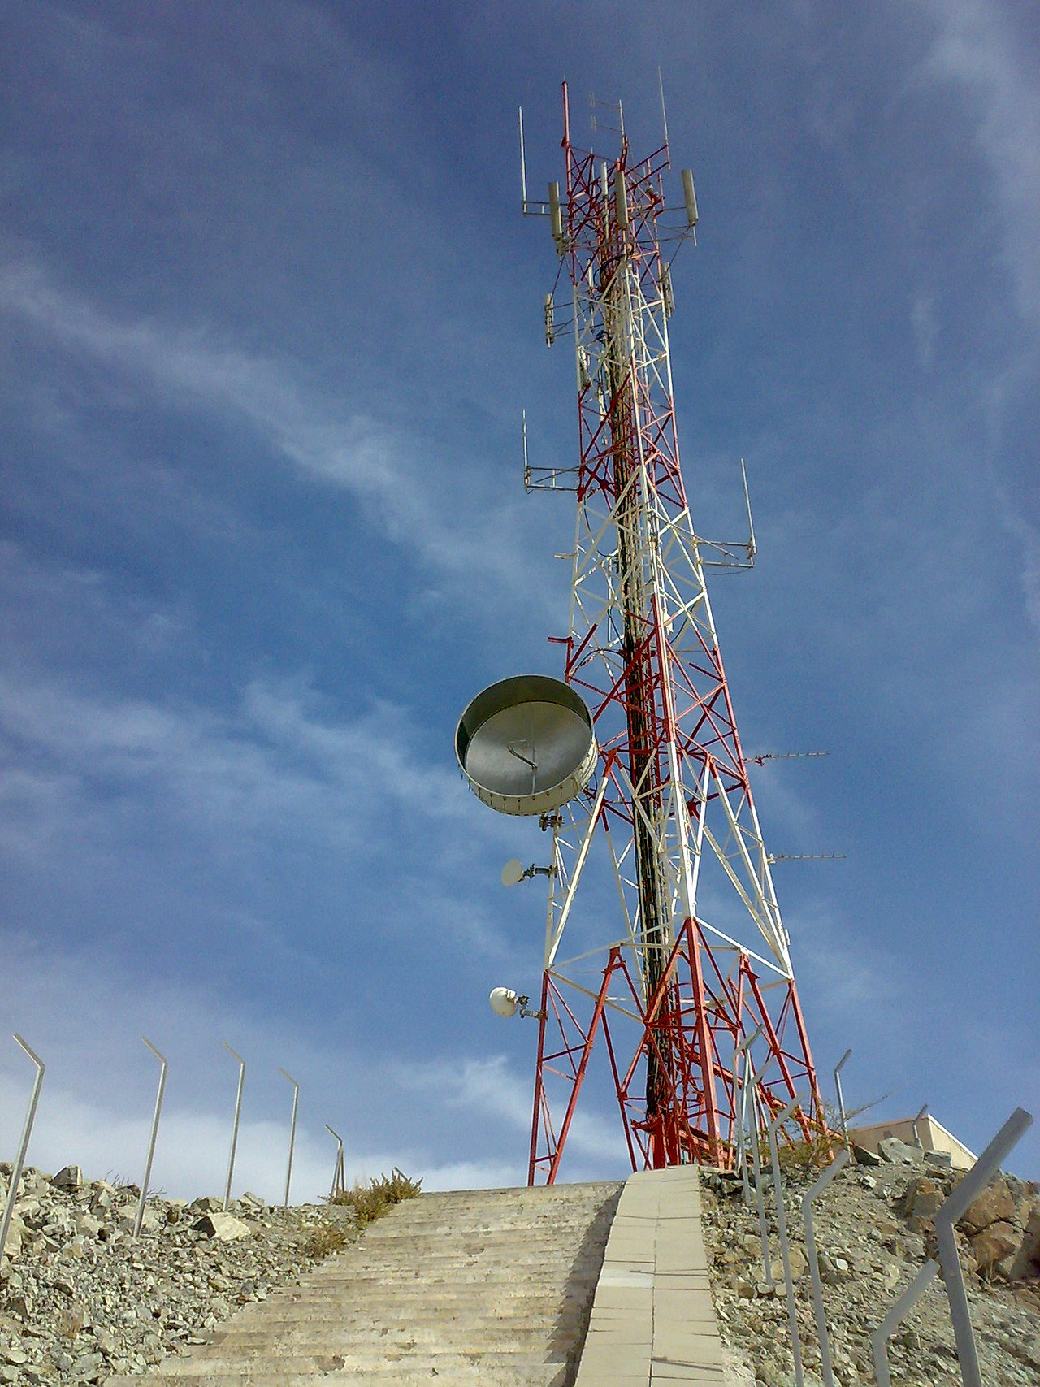

5G base station in UAE. Source:

Wikimedia Commons

Since the rollout of 5G in major cities such as New York, London, and Tokyo, there has been a significant increase in reports of unexplained fatigue and dizziness among residents living near 5G towers. The World Health Organization now acknowledges that the intense radiation emitted by these towers can penetrate human tissues, causing cellular damage.

The most alarming discovery is the link between 5G and the COVID-19 pandemic. Studies conducted in Wuhan, the first city to experience both a 5G rollout and a COVID-19 outbreak, show a direct correlation. Experts suggest that the 5G waves weakened the immune systems of residents, making them more susceptible to the virus.

Despite these findings, telecom companies and government agencies continue to promote 5G as the future of connectivity. However, growing public concern and mounting evidence suggest that urgent action is needed to mitigate the health risks associated with this technology.

Read the newspaper article on the previous page. Do you find what it says credible? Why (not)?

___________________________________________________________________

___________________________________________________________________

___________________________________________________________________



# Disinformation

Even if the article was perhaps convincingly written, the information in it is false, so-called 'disinformation.' What that is and how you can recognize whether information is disinformation, you will learn in the following two infoboxes.

Understanding Disinformation

Disinformation refers to the deliberate spread of false information to mislead people. It often aims to manipulate public opinion or obscure the truth.

Examples:

A fabricated news story about a political candidate, a fake scientific study claiming health benefits of a harmful substance.

### Recognizing Disinformation

Disinformation is false information spread deliberately to deceive people. Here are some common signs of disinformation:

Emotional Language:

Disinformation often uses strong emotional words to provoke a reaction.

Unverified Sources:

It may reference sources that are not credible or cannot be verified.

Clickbait Headlines:

Headlines that aim to grab attention but don't accurately reflect the content.

Manipulated Images:

Photos or videos that are altered or taken out of context.

Lack of Evidence:

Claims that are not supported by any evidence or data.

Anonymous Authors:

Content from unknown or anonymous sources can be a red flag.

Echo Chambers:

Information that is repeated in closed groups without external verification.

Always check the credibility of the source and confirm the information with multiple reliable sources before believing or sharing it.

What characteristics of disinformation can you identify in the newspaper article on the first page?

___________________________________________________________________

___________________________________________________________________

___________________________________________________________________

# Uncover disinformation

Now conduct your own research: On the website https://www.snopes.com/, disinformation is examined and scrutinized to determine its truthfulness. Visit the website and search for the topic described in the newspaper article. Which of the statements from the article are true, and which are fabricated?

### Your research

Use this space to write down what you found out.

___________________________________________________________________

___________________________________________________________________

___________________________________________________________________

___________________________________________________________________

|  |
| --- |
| Other examples of disinformation Talk about this question in class: Do you know any other examples of disinformation? |