Dragon  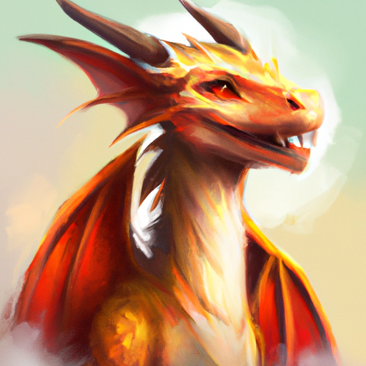  Health Points: 500  Attacks:  Fire Breath: 80  Claw Swipe: 60  The Dragon is a mythical creature with wings and scales, known for its ability to breathe fire. | Kraken  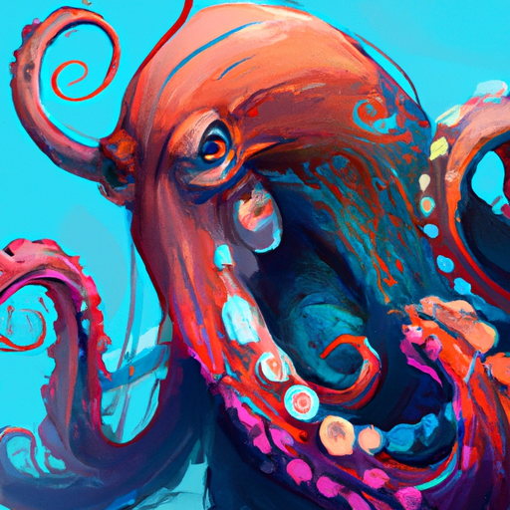  Health Points: 400  Attacks:  Tentacle Slam: 50  Ink Blast: 30  The Kraken is a legendary sea monster with massive tentacles. | Bigfoot  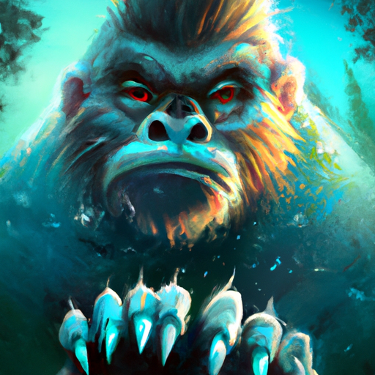  Health Points: 250  Attacks:  Slam: 40  Rock Throw: 20  Bigfoot is a cryptid said to inhabit remote forests, mountains, and swamps.

📋Löse folgende Aufgaben

1. The Kraken uses Tentacle Slam on the Dragon. How many Health Points does the Dragon have left?
500 - 50 = ______
2. Bigfoot performs a Slam on the Kraken. How many Health Points does the Kraken have after this attack?
400 - 40 = ______
3. The Dragon uses Fire Breath on Bigfoot. How many Health Points does Bigfoot have remaining?
250 - 80 = ______
4. The Kraken uses Ink Blast on the Dragon. How many Health Points does the Dragon have now?
450 - 30 = ______
5. Bigfoot throws a Rock at the Dragon, who still has 420 Health Points. How many Health Points does the Dragon have after this attack?
______ - ______ = ______
6. The Dragon performs a Claw Swipe on the Kraken. How many Health Points does the Kraken have left?
______ - ______ = ______
7. The Kraken uses Tentacle Slam on Bigfoot. How many Health Points does Bigfoot have remaining?
______ - ______ = ______
8. Bigfoot performs a Slam on the Dragon. How many Health Points does the Dragon have now?
______ - ______ = ______
9. The Dragon uses Fire Breath on the Kraken. How many Health Points does the Kraken have left?
______ - ______ = ______
10. The Kraken uses Ink Blast on Bigfoot. How many Health Points does Bigfoot have after this attack?
______ - ______ = ______

