## Arctic Ice Meltdown: The Unseen Cost of Climate Change

In September 2020, the Arctic sea ice reached its second-lowest extent since records began, covering only 3.74 million square kilometers. This dramatic decline is a stark indicator of climate change, largely driven by the persistent warming from greenhouse gases. The impact on the natural world has been profound; polar bears, reliant on sea ice for hunting, face diminishing habitats, threatening their survival.

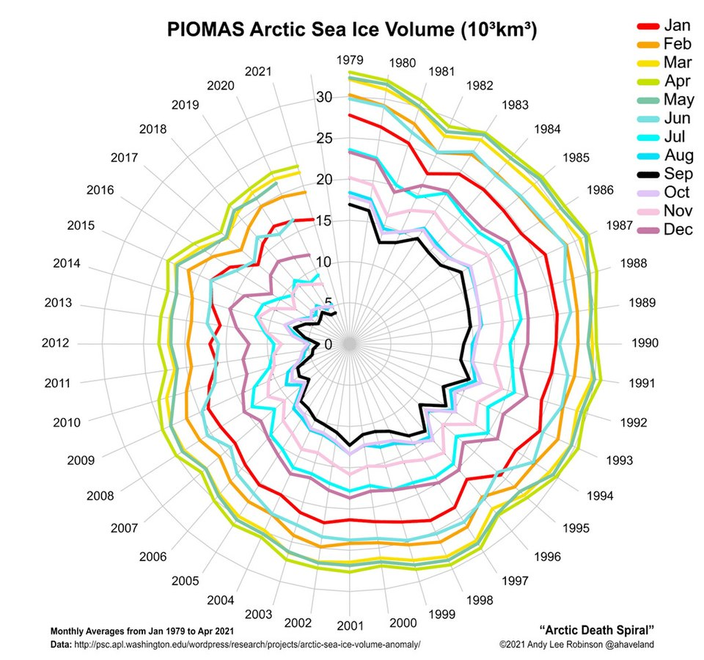

Source: Andy Lee Robinson, CC BY-SA 3.0

The geopolitical landscape is shifting as nations vie for control of new shipping routes opened by melting ice. In 2021, the Northern Sea Route saw unprecedented traffic, indicating a future where the Arctic might become a significant global trade corridor. This has sparked territorial disputes over resource-rich areas, complicating international relations.

Economically, the melting ice presents both opportunities and risks. While new trade routes promise reduced shipping costs, the fragility of Arctic infrastructure poses threats. As permafrost thaws, pipelines and roads risk collapse, jeopardizing investments worth billions. By 2030, increased shipping could further stress the Arctic ecosystem, exacerbating wildlife threats.

The Arctic's transformation serves as a cautionary tale of climate change's reach. If warming trends continue, we could see ice-free summers by the 2030s, with global repercussions including altered weather patterns and rising sea levels. The urgency to address climate change has never been more apparent.

Read the above newspaper article and take notes: Do such reports worry you? Why (or why not)? Then discuss in class.

___________________________________________________________________

___________________________________________________________________

___________________________________________________________________

|  |  |  |
| --- | --- | --- |
| Arctic 1800    In 1800, the Arctic region, encompassing parts of Northern Canada, Greenland, Russia, and the Arctic Ocean, was a pristine, largely unexplored wilderness. The climate was characterized by extremely cold winters with average temperatures plunging to -40°C, and cool summers with temperatures barely rising above freezing. Precipitation was predominantly in the form of snow, with annual amounts less than 50 cm. The ice mass was immense, with glaciers and sea ice covering vast areas. Periods of drought were rare, and the environment was marked by a stable, frigid climate with minimal human impact.  An untouched Arctic landscape in 1800 with vast ice sheets, towering glaciers, and minimal human presence. | Arctic 1950    By 1950, the Arctic, including areas like Northern Canada, Greenland, and Russia, had begun to witness increased human activity, particularly with the establishment of research stations. The climate remained cold, with winter temperatures around -35°C and summer temperatures occasionally reaching just above freezing. Average annual precipitation was still around 50 cm, mainly as snow. The ice mass, though slightly reduced, continued to dominate the landscape, with glaciers and sea ice still prevalent. Coastal areas experienced slightly warmer temperatures due to oceanic influences. Periods of drought were still uncommon, but the early signs of climate change were becoming noticeable.  An Arctic landscape in 1950 with research stations, reduced ice cover, and signs of early environmental changes. | Arctic Today    Today, the Arctic region is experiencing profound environmental changes due to climate change. Winter temperatures now average around -30°C, while summer temperatures frequently exceed 0°C. Precipitation patterns have shifted, with more rainfall during the warmer months and annual precipitation increasing slightly. The ice mass has significantly diminished, with substantial ice melt and reduced glacier size. The Arctic sea ice extent has shrunk drastically, leading to more open water. Coastal areas are warmer, and periods of drought have become more common. Human activity has intensified, with increased shipping routes and modern research facilities altering the once-pristine landscape.  A contemporary Arctic landscape with significant ice melt, modern infrastructure, and visible impacts of climate change. |

# Changed Climate: A Region in Transition

Read through the reports above regarding the situation in the years 1800, 1950, and today. Then complete the tasks listed below.

Name the key environmental changes observed in the Arctic region from 1800 to today.

___________________________________________________________________

___________________________________________________________________

___________________________________________________________________

Describe how human activity has evolved in the Arctic region from 1800 to the present day.

___________________________________________________________________

___________________________________________________________________

___________________________________________________________________

Explain the impact of rising temperatures on the Arctic ice mass over the years.

___________________________________________________________________

___________________________________________________________________

___________________________________________________________________

# The future

Make predictions in class about how further developments might look. Will the effects of climate change continue to intensify? What could be done to counteract this?

