# Test your knowledge

Do you know the capitals of EU member states? Match the countries with their capitals and then try to find all the countries on the map on the following page.

|  |  |  |
| --- | --- | --- |
| Austria |  | Paris |
| Belgium |  | Athens |
| Bulgaria |  | Prague |
| Croatia |  | Sofia |
| Cyprus |  | Vienna |
| Czech Republic |  | Brussels |
| Denmark |  | Helsinki |
| Estonia |  | Berlin |
| Finland |  | Zagreb |
| France |  | Copenhagen |
| Germany |  | Nicosia |
| Greece |  | Tallinn |

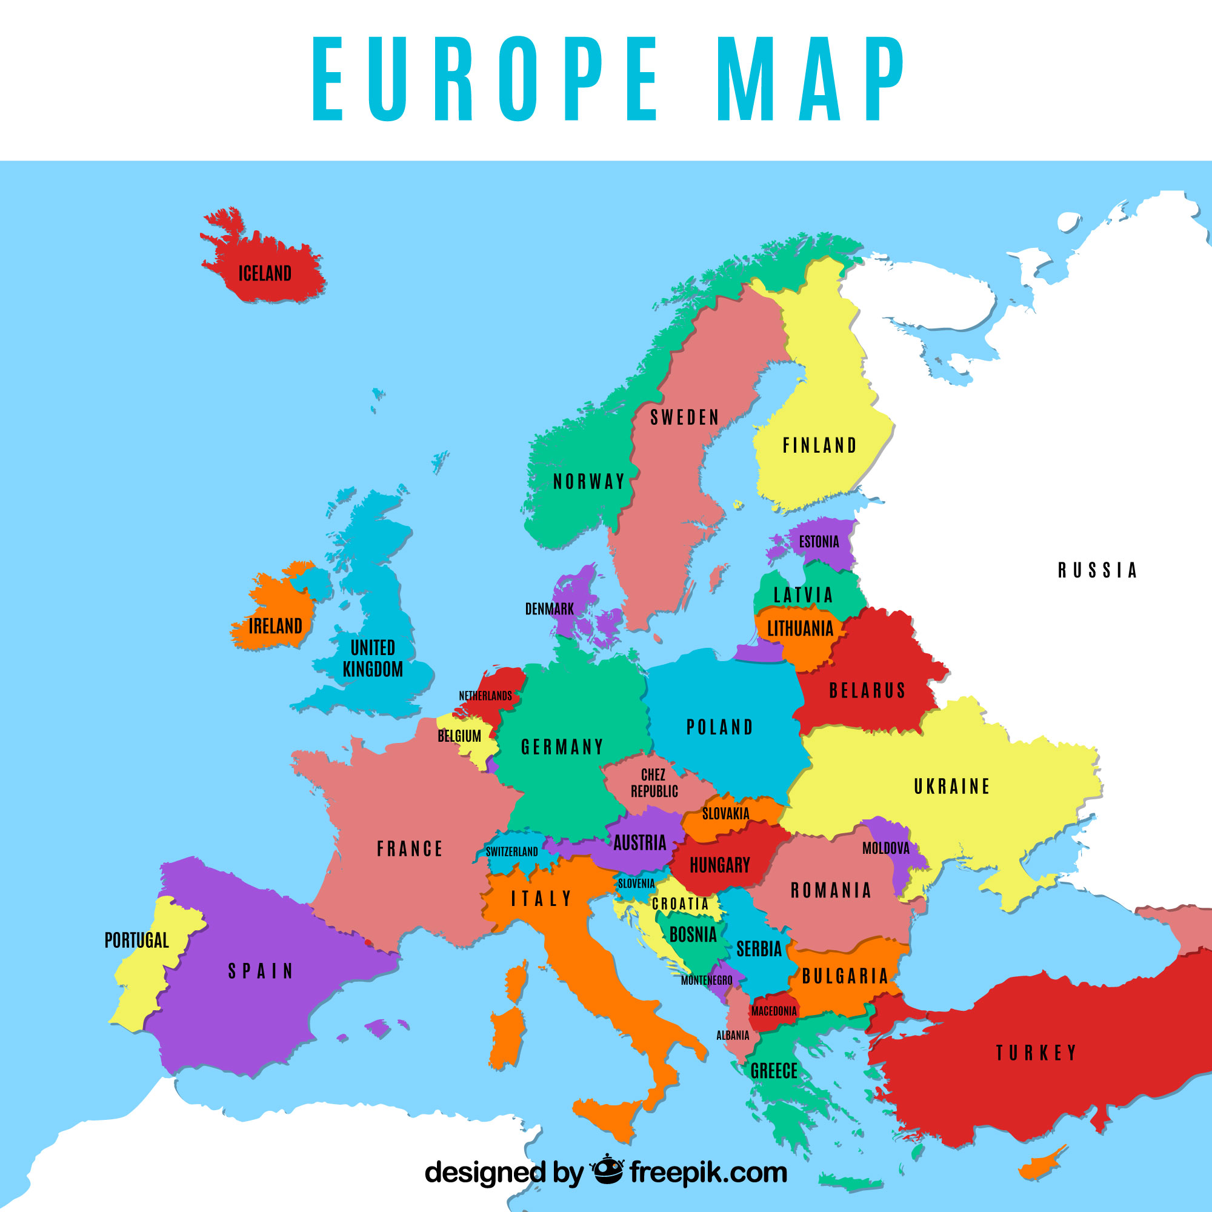

# Vacation in Europe

Which countries on the map have you already visited for vacation? Which country did you like best, and why? Take some notes, then talk about your experiences in class.

___________________________________________________________________

___________________________________________________________________

___________________________________________________________________

# EU Member States in Detail

Now learn more about an EU member state. Read the following text, then create a profile with all the important information about the country.

# Romania

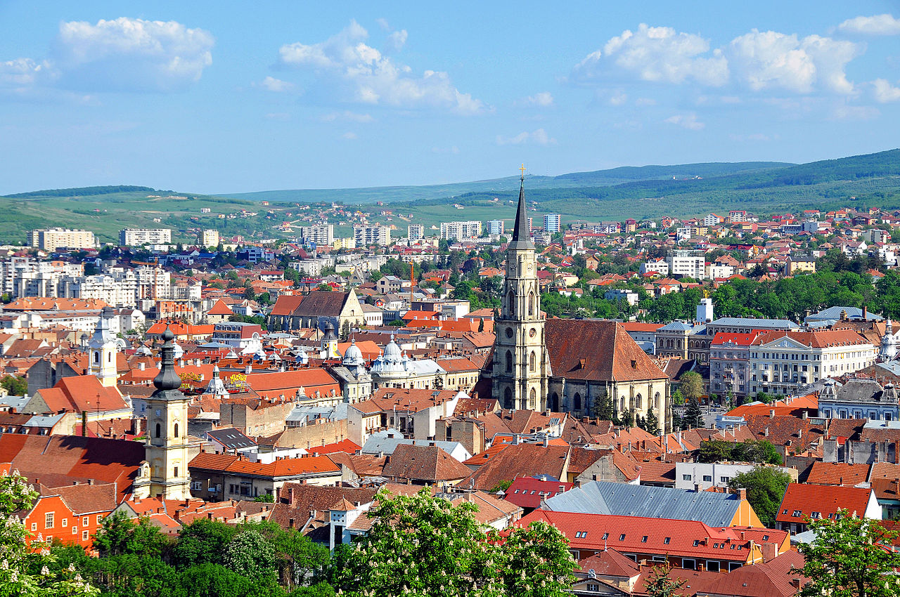

Source:

Wikipedia

Romania is a country in Europe. The capital city is Bucharest, which is the largest city. Romania has a population of around 19 million people. The country covers an area of 238,397 square kilometers.

Romania has diverse geography with mountains, plains, and a coastline along the Black Sea. The Carpathian Mountains run through the center of the country. One of the most famous rivers, the Danube, flows into the Black Sea through Romania's Danube Delta, which is a UNESCO World Heritage Site.

Romania is a semi-presidential republic. This means it has both a president and a prime minister. The president is Klaus Iohannis, and the prime minister is Marcel Ciolacu.

There are many interesting sights to see in Romania. Bran Castle, often called Dracula's Castle, is a popular tourist attraction. The beautiful painted monasteries in northern Moldavia are also UNESCO World Heritage Sites. The capital, Bucharest, is known for its large Parliament Palace.

Romania has many famous people. Nadia Comăneci, a gymnast, scored the first perfect 10 in the Olympics. Another famous Romanian is Vlad the Impaler, who inspired the story of Dracula. The country is also known for its talented artists, writers, and scientists.

Romania is a fascinating country with a rich history, beautiful landscapes, and many cultural treasures.

|  |  |
| --- | --- |
|  | Capital |
| Population |
| Size in km² |
| Geography | |
| Politics | |
| Sights | |
| World cultural heritage | |
| Famous personalities | |

|  |  |
| --- | --- |
|  | Capital  Bucharest |
| Population  around 19 million people |
| Size in km²  238,397 square kilometers |
| Geography  Diverse geography with mountains, plains, and a coastline along the Black Sea. The Carpathian Mountains run through the center. The Danube River flows into the Black Sea through the Danube Delta. | |
| Politics  Semi-presidential republic with a president and a prime minister. The president is Klaus Iohannis, and the prime minister is Marcel Ciolacu. | |
| Sights  Bran Castle (Dracula's Castle), painted monasteries in northern Moldavia, and the Parliament Palace in Bucharest. | |
| World cultural heritage  Danube Delta and painted monasteries in northern Moldavia. | |
| Famous personalities  Nadia Comăneci (gymnast who scored the first perfect 10 in the Olympics), Vlad the Impaler (inspired the story of Dracula). | |

# Let's Have an EU Party

Have another look at the information about your country that you collected in the profile. Afterwards, look at the collection of important words and phrases in the language of your country. Take a few minutes to prepare yourself, then walk around the classroom and meet people from other EU member states. Talk to them: tell them about your country and ask them questions about theirs. Try to say "Hello" in your country's language and try using some of the other phrases too.

### Important words

Hello = Bună
My name is = Numele meu este
Thank you = Mulțumesc
Bye = La revedere

