Sodium

Na
atomic number 11
alkali metal
23Na
NaCl
Sodium is a chemical element with the symbol (from Neo-Latin natrium) and the . It is a soft, silvery-white, highly reactive metal. Sodium is an , being in group 1 of the periodic table. Its only stable isotope is . The free metal does not occur in nature and must be prepared from compounds. Sodium is the sixth most abundant element in the Earth's crust and exists in numerous minerals such as feldspars, sodalite, and halite (). Many salts of sodium are highly water-soluble: sodium ions have been leached by the action of water from the Earth's minerals over eons, and thus sodium and chlorine are the most common dissolved elements by weight in the oceans.

Sodium was first isolated by Humphry Davy in 1807 by the electrolysis of sodium hydroxide. Among many other useful sodium compounds, sodium hydroxide (lye) is used in soap manufacture, and sodium chloride (edible salt) is a de-icing agent and a nutrient for animals including humans. Sodium is an essential element for all animals and some plants. Sodium ions are the major cation in the extracellular fluid (ECF) and as such are the major contributor to the ECF osmotic pressure and ECF compartment volume.

melting point
97.794°C
boiling point
882.940°C
Sodium at standard temperature and pressure is a soft silvery metal that combines with oxygen in the air, forming sodium oxides. Bulk sodium is usually stored in oil or an inert gas. Sodium metal can be easily cut with a knife. It is a good conductor of electricity and heat. Due to having low atomic mass and large atomic radius, sodium is the third-least dense of all elemental metals and is one of only three metals that can float on water, the other two being lithium and potassium. The of sodium is and the is .

NaCl
Na2CO3
NaHCO3
NaOH
NaNO3
Na2S2O3·5H2O
Na2B4O7·10H2O
Sodium compounds are of immense commercial importance, being particularly central to industries producing glass, paper, soap, and textiles. The most important sodium compounds are table salt (), soda ash (), baking soda (), caustic soda (), sodium nitrate (), di- and tri-sodium phosphates, sodium thiosulfate (), and borax (). In compounds, sodium is usually ionically bonded to water and anions and is viewed as a hard Lewis acid.

In the everyday context, sodium plays a crucial role, especially in the form of sodium chloride, commonly known as table salt. It is extensively used for seasoning and preserving food. Sodium is also vital for human health, regulating blood volume, blood pressure, osmotic equilibrium, and pH. The sodium-potassium pump in human cells is essential for nerve function and muscle contraction.

In summary, sodium is a highly reactive and essential element with significant roles in both industrial applications and biological systems. Its unique properties and widespread occurrence make it a vital component of many natural and human-made processes.

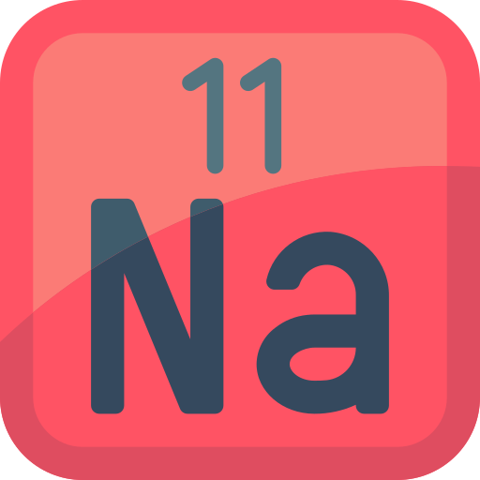 | Name
 | Symbol
 | Atomic number
Element category

Appearance

Properties

Special features

Name
Sodium
Symbol
Na (from Neo-Latin natrium)
Atomic number
11
Element category
Alkali metal (Group 1 of the periodic table)
Appearance
Soft, silvery-white, highly reactive metal
Properties
Sodium is a highly reactive metal with a low density, being the third-least dense metal. It has a melting point of 97.794°C and a boiling point of 882.940°C. Sodium is a good conductor of electricity and heat. It combines with oxygen in the air to form sodium oxides and is usually stored in oil or an inert gas.
Special features
Sodium was first isolated by Humphry Davy in 1807 through the electrolysis of sodium hydroxide. It is essential for all animals and some plants, playing a major role in regulating blood volume, blood pressure, osmotic equilibrium, and pH. Sodium ions are the major cation in the extracellular fluid and contribute to the ECF osmotic pressure and compartment volume. Sodium compounds are crucial in various industries such as glass, paper, soap, and textiles. Sodium does not occur freely in nature and must be prepared from compounds. Sodium chloride (table salt) is extensively used for seasoning and preserving food.

Select the correct temperature.
State of Matter | Temperature (°C)
Solid
Liquid
Gas

True or False?

Sodium is an essential element for all animals and some plants.
True False

Sodium's atomic number is 10.
True False

Sodium metal can be easily cut with a knife.
True False

Sodium is stored in water to prevent it from reacting with the air.
True False

The melting point of sodium is 97.794°C.
True False

Sodium is denser than all other elemental metals.
True False

Sodium was first isolated by Humphry Davy in 1807.
True False

Sodium chloride is commonly known as baking soda.
True False
4
6
1
2
8
3
7
5

Across
1 Group of elements to which sodium belongs (6)
3 Process used by Davy to isolate sodium (12)
2 An important use of sodium hydroxide (4)
7 Sodium ion's role in extracellular fluid (6)
5 Sodium's appearance at standard temperature and pressure (7)

Down
2 Common name for sodium chloride (4)
4 Essential for nerve function and muscle contraction (4)
5 Element commonly stored in oil or an inert gas (6)
6 Common mineral form of sodium chloride (6)
8 Type of metal sodium is classified as (8)

