# The Birch Tree

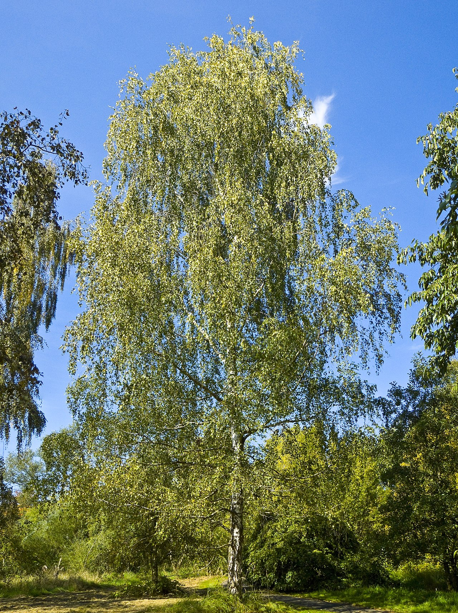

File:Betula pendula 001.jpg

CC BY 2.5

Source:

The birch tree, known in Latin as Betula, is a fascinating tree. It can grow up to 30 meters tall and live for around 100 years. Birch trees bloom in the spring, usually in April and May. They produce small fruits called samaras, which have tiny wings that help them float in the wind.

Birch leaves are simple and have a triangular shape with serrated edges. The wood of the birch tree is strong and is often used to make furniture and plywood. Birch bark is thin and can be peeled off in paper-like layers. It is usually white or silvery-gray and has black markings.

Birch trees are found in many parts of the world, especially in cooler regions. They grow in Europe, North America, and parts of Asia. These trees like to live in forests and along riverbanks.

Birch trees are very important because they provide homes for many animals and insects. They help keep the soil healthy and can even be used to make syrup and other products. Birch trees are not only beautiful but also very useful!

### Word search puzzle

Find the words below in this letter salad. Mark the words you have found.

|  |  |  |  |  |  |  |  |  |  |
| --- | --- | --- | --- | --- | --- | --- | --- | --- | --- |
| L | U | F | B | K | O | Y | Y | X | A |
| E | J | A | T | O | B | D | F | C | Y |
| A | P | R | A | V | W | E | Z | V | B |
| V | A | S | K | N | V | W | M | F | K |
| E | Y | Z | C | O | B | A | L | G | C |
| S | A | M | A | R | A | U | X | V | F |
| G | K | S | X | B | D | B | F | C | E |
| O | T | N | Q | T | X | E | O | L | K |
| T | R | S | F | O | B | I | R | C | H |
| B | E | T | U | L | A | N | E | C | I |
| C | E | A | B | U | R | L | S | E | C |
| Y | U | F | B | N | K | W | T | U | D |

BIRCH

BETULA

TREE

SAMARA

WOOD

BARK

LEAVES

FOREST

|  |  |  |
| --- | --- | --- |
| Birch Leaf    Hello, I am the Birch Leaf! In spring, I grow fresh and green on the branches of the birch tree. My job is to help the tree breathe by taking in sunlight and air to make food. In autumn, I turn yellow or brown before falling to the ground to make way for new leaves next year.  The birch leaf is triangular with serrated edges. It is 3 to 7 cm long and turns yellow in the autumn. | Birch Bark    Hi, I am the Birch Bark! I am thin and can be peeled off in paper-like layers. I protect the birch tree from the cold and pests. My white or silvery-gray color with black markings makes the birch tree easy to recognize.  Birch bark is thin, white or silvery-gray with black markings. It can be peeled off in layers and is used for making various products. | Birch Fruit  Greetings, I am the Birch Fruit! I am called a samara and have tiny wings that help me float in the wind. I carry the seeds that help new birch trees grow in different places.  The birch fruit, known as a samara, is small and has wings that allow it to be carried by the wind. |

### True or False? Mark the correct answer.

###### **Birch trees can grow up to 30 meters tall.**

True False

###### **Birch trees usually bloom in the winter.**

True False

###### **Birch leaves have a triangular shape with serrated edges.**

True False

###### **Birch bark is thick and cannot be easily peeled off.**

True False

###### **Birch trees are only found in Europe.**

True False

###### **Birch wood is often used to make furniture.**

True False

###### **Birch trees help keep the soil healthy.**

True False

###### **Birch trees' small fruits are called samaras.**

True False

|  |  |
| --- | --- |
|  | Latin name |
| Height |
| Age |
| Flowering time | |
| Fruit | |
| Leaf shape | |
| Characteristics of the wood | |
| Characteristics of the bark | |
| Occurrence | |

|  |  |
| --- | --- |
|  | Latin name  Betula |
| Height  up to 30 meters |
| Age  around 100 years |
| Flowering time  April and May | |
| Fruit  samaras with tiny wings | |
| Leaf shape  triangular with serrated edges | |
| Characteristics of the wood  strong, used to make furniture and plywood | |
| Characteristics of the bark  thin, paper-like layers, white or silvery-gray with black markings | |
| Occurrence  Europe, North America, parts of Asia; forests and riverbanks | |