Gallery walk
gallery walk
This worksheet will tell you all you need to know about the method which you might encounter in many of your school subjects. It is not about actually going to a museum, but about presenting a project that has been developed in groups. You will learn exactly how it works in the following video.
 | Youtube: Gallery Walk  To watch the youtube video just scan the QR code.  https://www.youtube.com/watch?v=pSt5echeRrM

Choose the correct answer for each question.

What is the first step students must take in the gallery walk activity?
Stand by the assigned poster. Rotate to the next poster. Read and discuss the support materials with group members. Create a poster individually.

What must each group include in their poster for the gallery walk?
Only words. Only pictures. Only the names of group members. Both words and pictures.

If you are standing by the poster you helped create, what is your responsibility?
To move to the next poster without explanation. To explain the poster to the new group. To critique the poster. To create a new poster.

How are students assigned to stand by specific posters during the gallery walk?
By alphabetical order. By choosing their favorite poster. By random draw. By being given a number by the teacher.

What happens when the teacher says 'rotate' during the gallery walk?
Students create a new poster. Students return to their seats. Students take a break. Students move to the next poster.

Why is it important for everyone in the group to add something to the poster?
To ensure the poster is artistic. To finish the poster faster. To make the poster larger in size. To guarantee individual contributions and collaborative effort.

Which aspects do you think are important for delivering a successful presentation during a gallery walk?
___________________________________________________________________
___________________________________________________________________
___________________________________________________________________

Developing a questionnaire

Now, collaboratively develop a questionnaire in class that you can use to evaluate your classmates' projects during the gallery walk and to provide them with feedback afterward.

Questionnaire
Use this space to take notes about what to include in the questionnaire.

___________________________________________________________________

___________________________________________________________________

___________________________________________________________________

___________________________________________________________________

Additional information for teachers

Sample solution for creating the questionnaire

Name of the presenter:

Topic of the presentation:

How informative was the presentation?

Very informative

Informative

Hardly informative

Not informative at all

How well was the presentation delivered?

Very well

Well

Poorly

Very poorly

How well did the presenter know the topic?

Very well

Well

Not well

Not at all

Did the presentation spark interest in the topic?

Yes, definitely!

Yes, a little

Not really

Not at all

What did you like best about the presentation?

Additional information for teachers

If possible, copy the cards for the following task in large format and place them in different corners of the classroom.

Note: Instead of using the prepared cards, you can also let the students design their own posters in groups of four or five students and then afterwards divide them into new groups as described in the video.

Participating in a gallery walk
Now you can test for yourselves how the presentation part of a gallery walk works. Form groups of four. Each person in the group should carefully look at one of the four cards below, read the information attentively, and think about how to best present the topic. If necessary, research additional information. Meanwhile, the cards will be displayed in large format at four different locations in the room.
Paris  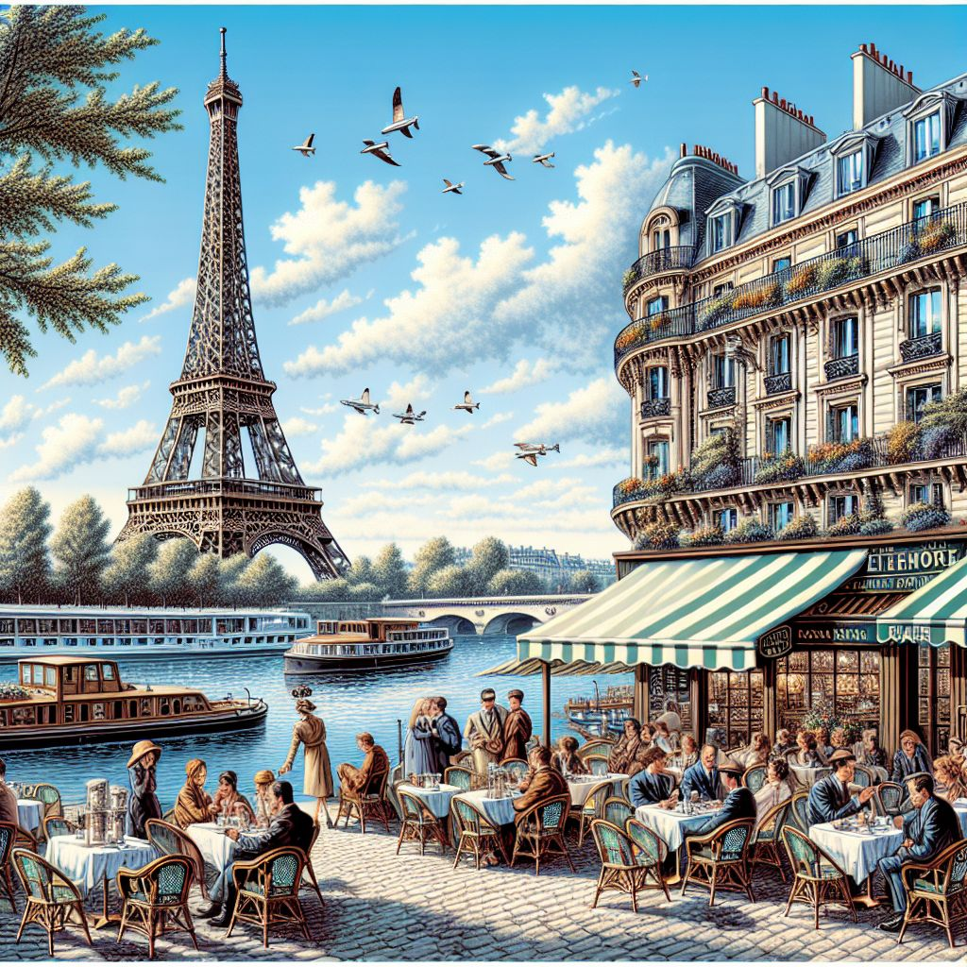  Country: France  Founded: 3rd century BC  Sights: Eiffel Tower, Louvre Museum, Notre-Dame Cathedral  Population: ~2.1 million  Nickname: 'City of Light'  Paris, the capital of France, is famed for its romantic ambiance, historic landmarks like the Eiffel Tower, and cultural treasures such as the Louvre Museum. Fun fact: The Eiffel Tower was initially criticized and called an 'eyesore' by many Parisians! | Rome  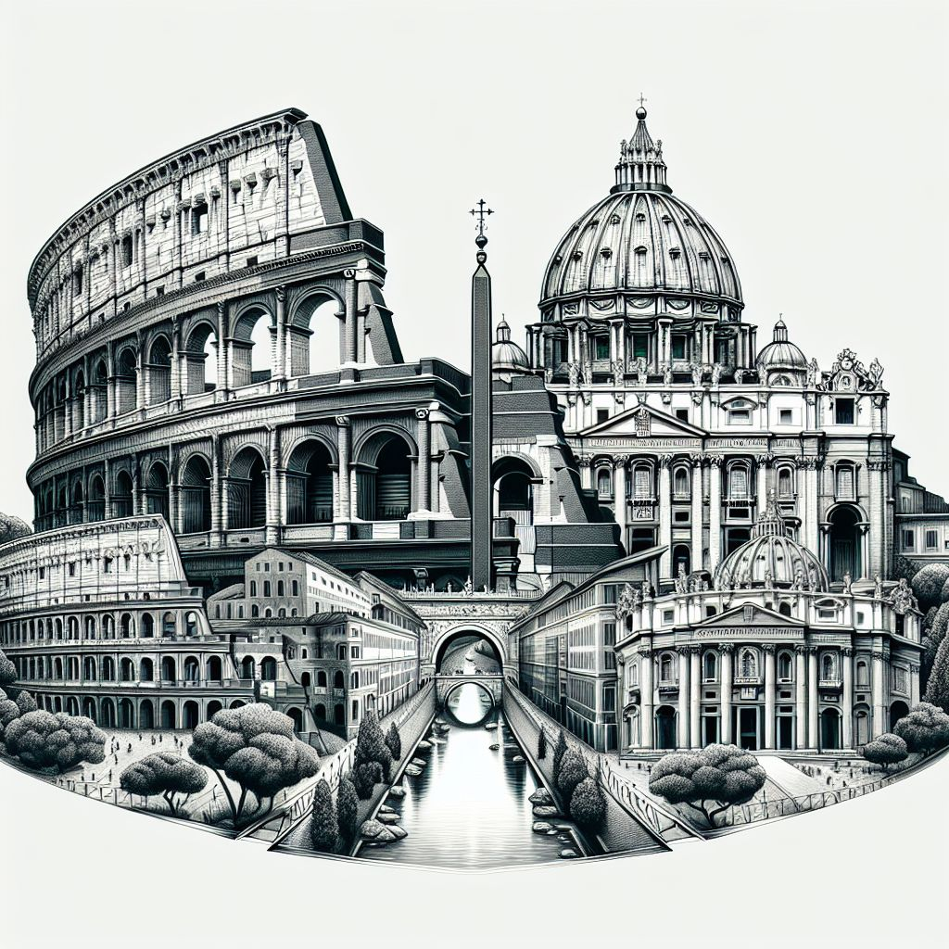  Country: Italy  Founded: 753 BC  Sights: Colosseum, Vatican City, Pantheon  Population: ~2.8 million  Nickname: 'The Eternal City'  Rome, the capital of Italy, is a city steeped in history, from the Roman Empire to the Renaissance. Major attractions include the Colosseum and Vatican City. Fun fact: Rome has a museum dedicated entirely to pasta!
Berlin  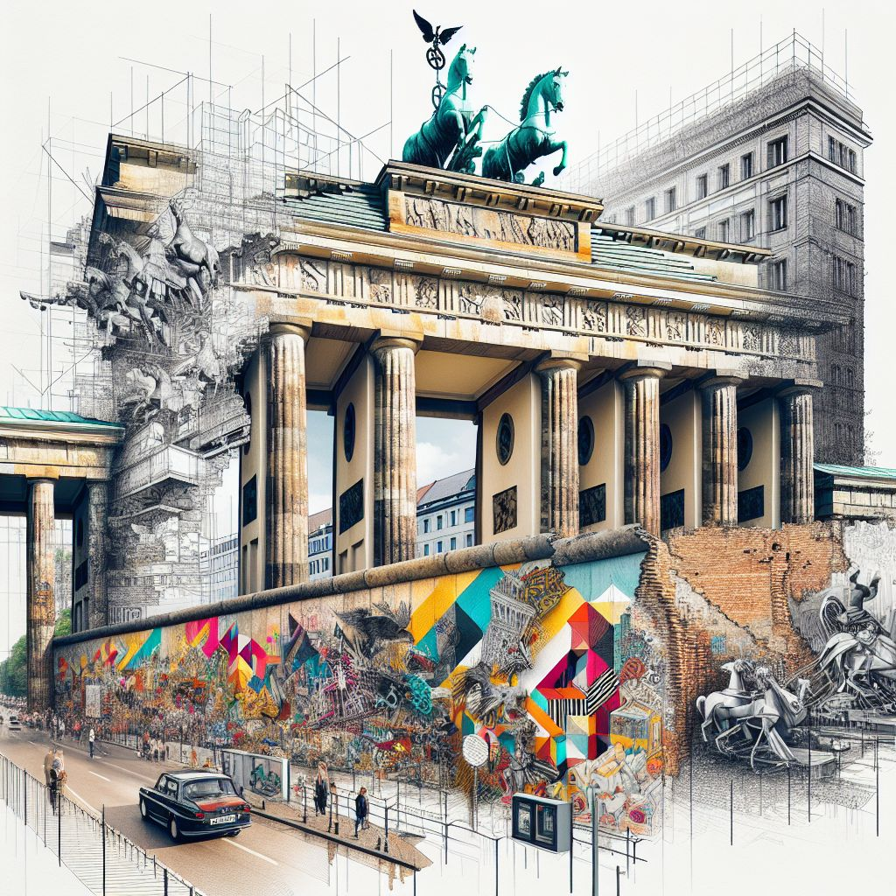  Country: Germany  Founded: 13th century  Sights: Brandenburg Gate, Berlin Wall, Museum Island  Population: ~3.6 million  Nickname: 'The Grey City'  Berlin, Germany's capital, is known for its turbulent history, vibrant culture, and modern architecture. Key sights include the Brandenburg Gate and remnants of the Berlin Wall. Fun fact: Berlin has more bridges than Venice! | London  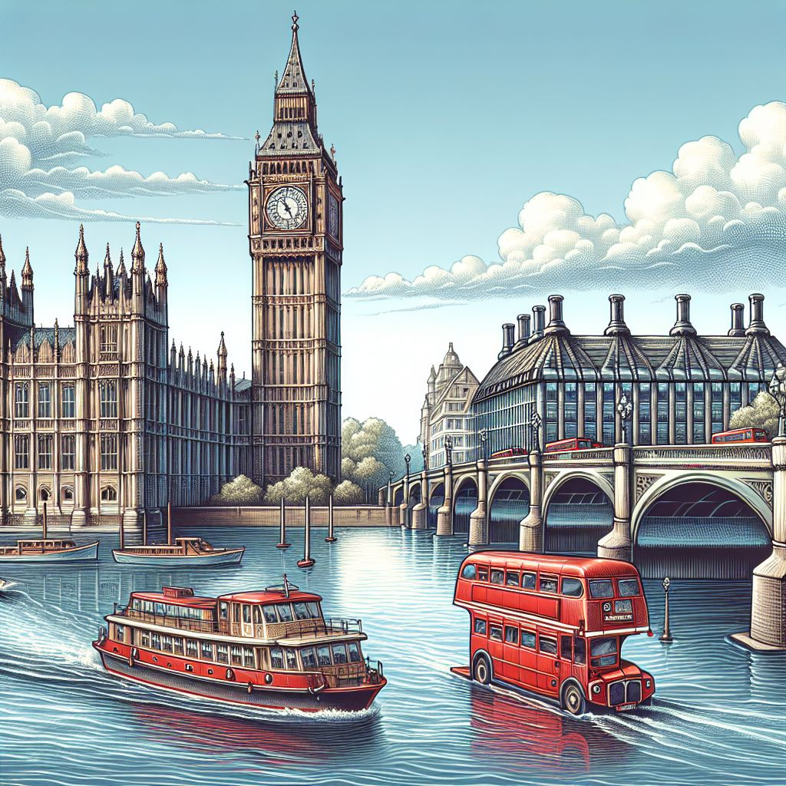  Country: United Kingdom  Founded: AD 43  Sights: Big Ben, Tower of London, Buckingham Palace  Population: ~9 million  Nickname: 'The Big Smoke'  London, the capital of the United Kingdom, is a melting pot of history and modernity with iconic landmarks like Big Ben and Buckingham Palace. Fun fact: The Great Fire of London in 1666 destroyed almost all of the city!

Participating in a gallery walk
After the preparation time, your tour begins:

Gather in front of one of the posters in your group.
Your teacher will give the signal for you to start.
The person from the group who has studied the topic will present it to the other students. They will take notes on their questionnaire during the presentation.
After a predetermined time (e.g., 3 minutes), the teacher will give the signal to switch. Now all groups move clockwise to the next poster, and the expert presents it to the rest of the group.
Once everyone has presented their poster, the gallery walk is finished.

Reflection

Go back to your groups of four and give each other feedback: What did you think of the presentations? What are your suggestions for improvement?

Discuss the gallery walk in general: How did you like the method? What did you find difficult, and what did you enjoy?

