|  |
| --- |
| Introduction Today you will get to know an artist and create your own painting. |

Frida Kahlo

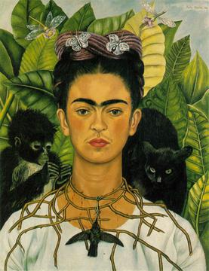

Self-Portrait with Thorn Necklace and Hummingbird

Source:

Self-Portrait with Thorn Necklace and Hummingbird - Wikipedia

### 📝 Task

Do you know this picture or the artist? Write down your thoughts.

___________________________________________________________________

___________________________________________________________________

___________________________________________________________________

___________________________________________________________________

# Frida Kahlo and Her Painting "Self-Portrait with Thorn Necklace and Hummingbird"

Frida Kahlo was a famous painter from Mexico. She was born on July 6, 1907, and she loved to paint pictures of herself. Frida's paintings are very colorful and often show her feelings and experiences. When Frida was a child, she had polio, which made her leg weak. Later, she was in a bad bus accident that caused her a lot of pain for the rest of her life.

One of her well-known paintings is "Self-Portrait with Thorn Necklace and Hummingbird." In this painting, Frida shows herself with a thorn necklace that looks painful. A small black hummingbird is hanging from the necklace. Frida's face looks strong and serious. She often painted herself with symbols that showed her feelings. The thorn necklace might show her pain, and the hummingbird could represent hope or freedom.

Frida Kahlo's art is loved by many people all around the world because it tells powerful stories about her life and emotions.

📌 Now design your own picture. Read the task and enter your title in the blank field.

🖌 Create a drawing of yourself with symbols that show your feelings, just like Frida Kahlo did in her painting 'Self-Portrait with Thorn Necklace and Hummingbird.' Add a special object or animal that represents something important to you.

___________________________________________________________________

___________________________________________________________________

___________________________________________________________________