# The Civil Rights Movement: A Struggle for Equality and Justice

Civil Rights Movement

The , a pivotal era in American history, spanned the 1950s and 1960s, marking a profound period of activism aimed at ending racial segregation and discrimination against African Americans. This movement sought to secure African Americans' legal and civil rights, which had been systematically denied for centuries. It was a struggle for justice and equality that extended beyond the borders of the United States, inspiring numerous other global rights movements.

Martin Luther King Jr.

Rosa Parks

Malcolm X

National Association for the Advancement of Colored People (NAACP)

Southern Christian Leadership Conference (SCLC)

Montgomery Bus Boycott

At the heart of the Civil Rights Movement were courageous leaders and ordinary citizens who risked everything to fight for equality. Figures such as , , , and organizations like the and the became emblematic of the struggle. These leaders utilized nonviolent protest and civil disobedience as primary tactics, drawing on the teachings of Mahatma Gandhi. The movement's strategies included boycotts, such as the , sit-ins, marches, and legal challenges against discriminatory laws.

March on Washington for Jobs and Freedom

One of the most iconic events was the 1963 , where Martin Luther King Jr. delivered his historic "I Have a Dream" speech, envisioning a future where individuals would be judged by their character rather than the color of their skin. This event exemplified the movement's ability to rally support across different races and backgrounds.

Civil Rights Act of 1964

Voting Rights Act of 1965

The Civil Rights Movement achieved significant legislative victories, most notably the , which outlawed discrimination based on race, color, religion, sex, or national origin, and the , which removed barriers to voting for African Americans and other minority groups. These laws marked a turning point, although they did not immediately eliminate all forms of discrimination.

The legacy of the Civil Rights Movement is enduring, reminding future generations of the power of collective action and the ongoing struggle for equality and justice. Its history teaches valuable lessons about courage, resilience, and the importance of fighting for what is right, principles that continue to resonate and inspire movements for social justice today.

### What are the causes and effects?

|  |  |
| --- | --- |
| Cause | Effect |
| Brown v. Board of Education (1954) | Declared state laws establishing separate public schools for black and white students unconstitutional |
| Systematic oppression and inequality | Sparked the Civil Rights Movement to end racial discrimination and segregation |
| Montgomery Bus Boycott (1955) | Resulted in the desegregation of the city's buses and brought national attention to the movement |
| Nonviolent protests, sit-ins, and boycotts | Challenged segregation and discrimination, gaining momentum for the movement |
| Leadership of Martin Luther King Jr. | Inspired millions and helped to galvanize the movement with nonviolent resistance and civil disobedience |
| Civil Rights Act (1964) | Outlawed discrimination based on race, color, religion, sex, or national origin |
| Voting Rights Act (1965) | Prohibited racial discrimination in voting |
| Opposition and violence against activists | Many activists were arrested, beaten, or killed for their efforts |
| Deep-seated racial tensions and divisions | Exposed the ongoing racial issues within American society |

### What are the causes and their effects?

Cause: Martin Luther King Jr. delivered his 'I Have a Dream' speech.

___________________________________________________________________

Cause: The Civil Rights Act of 1964 was passed.

___________________________________________________________________

Cause: The Voting Rights Act of 1965 was enacted.

___________________________________________________________________

Cause: Activists organized sit-ins at segregated lunch counters.

___________________________________________________________________

Cause: The March on Washington for Jobs and Freedom took place.

___________________________________________________________________

## Sometimes causes have long lasting effects. A timeline can help visualize the connections.

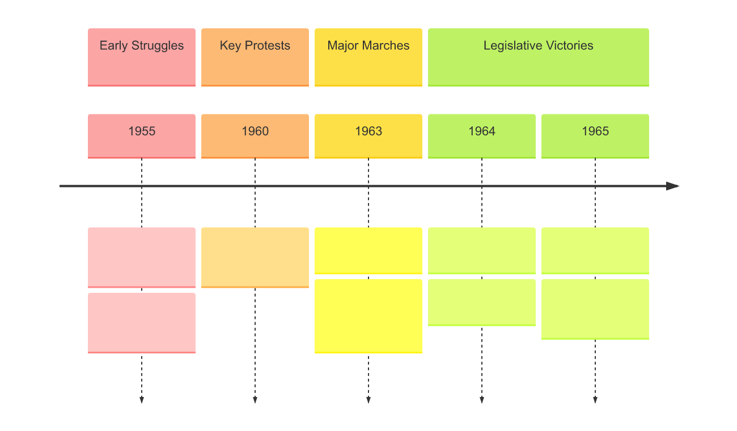

### Practice analyzing cause and effect

Choose one event from examples above and analyze cause and effect in detail

___________________________________________________________________

___________________________________________________________________

___________________________________________________________________

___________________________________________________________________