# Photosynthesis

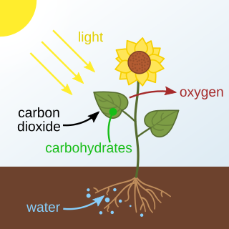

Source:

Wikimedia Commons

photosynthesis

Imagine you’re playing soccer on a sunny day and notice how energized you feel after drinking a refreshing glass of lemonade. Just like you need energy from food and drink, plants also need energy to grow. But instead of eating, they use sunlight through a process called .

Photosynthesis

is the process by which green plants, algae, and some bacteria convert light energy into chemical energy, stored in glucose. This process primarily takes place in the leaves of plants, specifically in the chloroplasts that contain chlorophyll, the pigment that gives plants their green color.

The theory behind photosynthesis is that plants take in carbon dioxide (CO₂) from the air and water (H₂O) from the soil. Using sunlight, they convert these substances into glucose (a type of sugar) and oxygen (O₂). The overall chemical reaction can be summarized as:

One concrete example of photosynthesis is how trees produce oxygen, which is essential for humans and animals to breathe. Another example is the production of food crops like wheat and corn, which we consume for energy.

The main concepts related to photosynthesis include:

Chlorophyll

: The green pigment in plants that captures light energy.

Chloroplasts

: The structures within plant cells where photosynthesis occurs.

Light-dependent reactions

: These occur in the thylakoid membranes of the chloroplasts and involve the absorption of light, which is used to produce ATP and NADPH.

Calvin cycle (light-independent reactions)

: This takes place in the stroma of the chloroplasts, where the ATP and NADPH produced in the light-dependent reactions are used to convert CO₂ into glucose.

Photosynthesis is a vital process for life on Earth. It not only provides the oxygen we breathe but also forms the basis of the food chain. Without photosynthesis, life as we know it would not be possible.

### Tick the right box:

###### **Which part of the plant cell captures light energy during photosynthesis?**

Nucleus Cell Wall Mitochondria Chlorophyll

###### **What are the end products of the light-dependent reactions?**

Carbon Dioxide and Water ATP and NADPH Starch and Oxygen Glucose and Oxygen

###### **In which part of the chloroplast does the Calvin cycle take place?**

Nucleus Stroma Mitochondria Thylakoid Membranes

###### **What is one of the primary roles of glucose produced during photosynthesis?**

To release oxygen into the atmosphere To capture sunlight To provide energy for the plant To absorb water

###### **Which of the following is a byproduct of photosynthesis that benefits humans?**

Nitrogen Methane Oxygen Carbon Dioxide

###### **How does placing a plant near a sunny window affect its photosynthesis process?**

It stops the light-dependent reactions. It reduces the amount of oxygen released by the plant. It increases the absorption of sunlight, enhancing glucose production. It decreases the need for water and carbon dioxide.

Name the main parts of a plant involved in photosynthesis.

___________________________________________________________________

___________________________________________________________________

___________________________________________________________________

Describe how plants use sunlight to make their own food.

___________________________________________________________________

___________________________________________________________________

___________________________________________________________________

Explain why photosynthesis is important for both plants and humans.

___________________________________________________________________

___________________________________________________________________

___________________________________________________________________