# Dr. Seuss

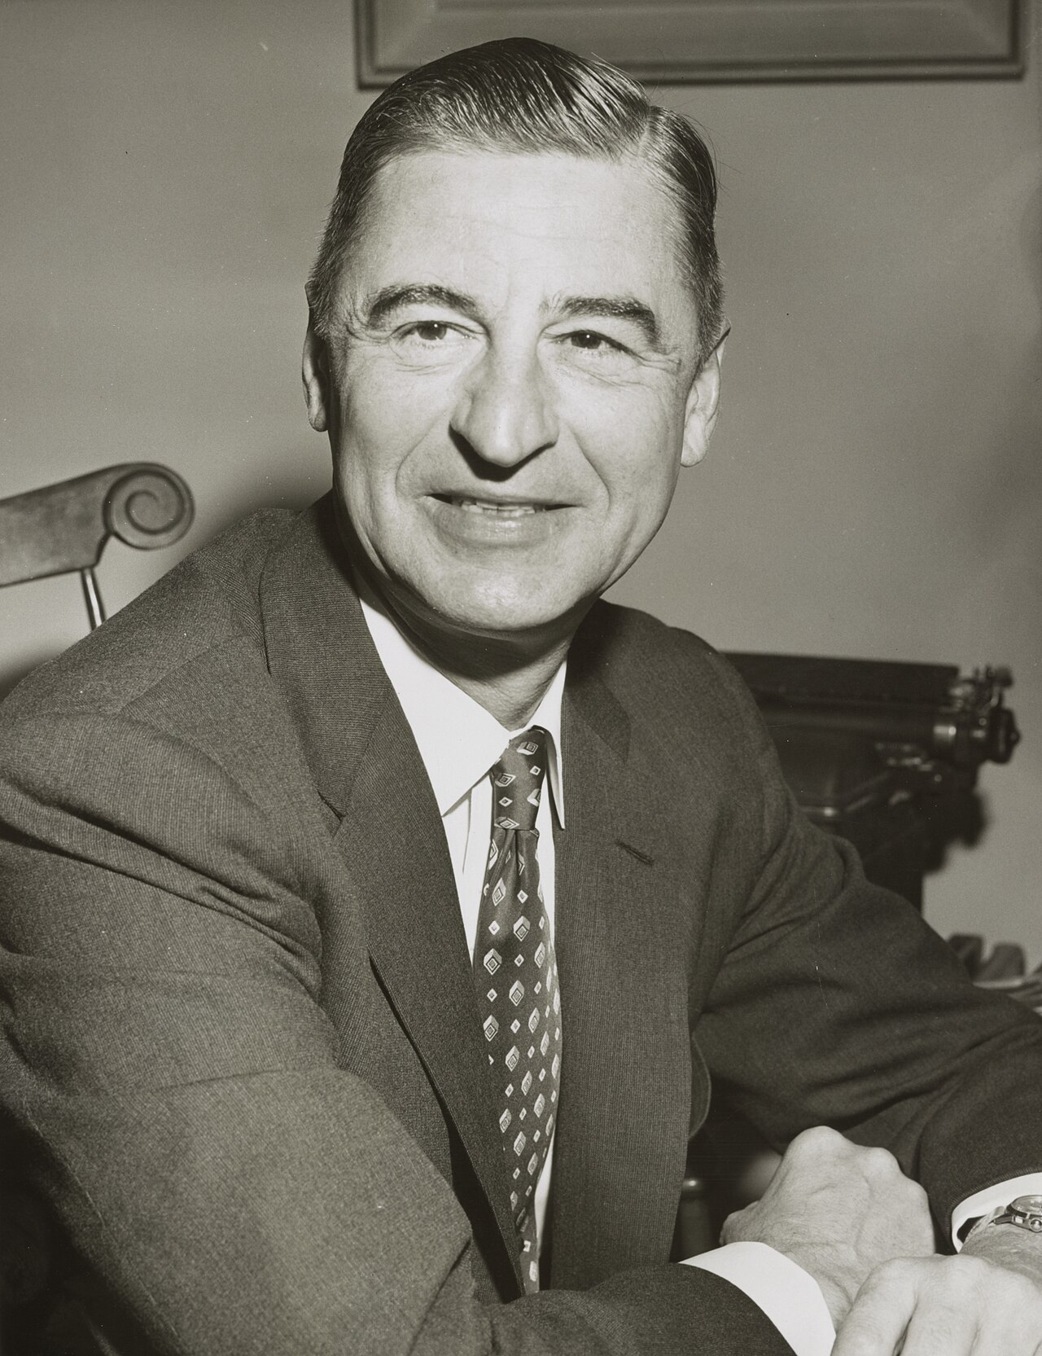

Source:

Wikimedia Commons

Dr. Seuss is a famous author from the United States. He was born Theodor Seuss Geisel on March 2, 1904, in Springfield, Massachusetts. He passed away on September 24, 1991, in San Diego, California. Dr. Seuss is well-known for writing many beloved children's books, including the famous Christmas story "How the Grinch Stole Christmas!"

Besides the Grinch, Dr. Seuss wrote many other popular stories. Some of his most famous books include "The Cat in the Hat," which tells the tale of a mischievous cat who visits two children, and "Green Eggs and Ham," a fun story about trying new things. Another favorite is "Horton Hears a Who!," which teaches the important lesson that "a person's a person, no matter how small."

Dr. Seuss had a very creative and playful writing style, often using rhymes and made-up words to make his stories fun and engaging. He also worked as a political cartoonist, illustrator, poet, animator, and filmmaker.

An interesting fact about Dr. Seuss is that he used several pen names, including Theo LeSieg and Rosetta Stone. He studied at Dartmouth College and later attended Lincoln College, Oxford.

Dr. Seuss's stories have been loved by generations of children and adults alike. They are not only entertaining but also teach important lessons about kindness, acceptance, and the joy of reading. So the next time you pick up a Dr. Seuss book, get ready for a whimsical adventure filled with colorful characters and delightful rhymes!

|  |
| --- |
| The author Read the text about the author of the story on the previous page and answer the questions. |

### For each sentence, choose if it's true or false.

###### **Dr. Seuss was born on March 2, 1904, in Springfield, Massachusetts.**

True False

###### **Dr. Seuss wrote the famous children's book 'Green Eggs and Ham'.**

True False

###### **Dr. Seuss passed away on September 24, 1981, in San Diego, California.**

True False

###### **The Cat in the Hat is about a mischievous dog who visits two children.**

True False

###### **Dr. Seuss used the pen name Theo LeSieg.**

True False

###### **Horton Hears a Who! teaches the lesson that 'a person's a person, no matter how small'.**

True False

|  |  |
| --- | --- |
|  | Audio Content  To listen to audio content just scan the QR code and listen to it on the digital worksheet.  https://to-teach.ai/worksheet/PbPGKnR4GBXfiape3JXr |

### Put the parts of the story in the correct order.

|  |  |
| --- | --- |
|  | On Christmas morning, he is surprised to hear the Whos singing joyfully despite having nothing. |
|  | Determined to stop Christmas from coming, the Grinch devises a plan to steal all the Christmas items from the Whos. |
|  | He goes from house to house, taking all the Christmas decorations, presents, and food, and stuffs them into a big sack. |
|  | The Whos in Whoville love Christmas and celebrate it joyfully, which annoys the Grinch. |
|  | The Grinch believes that without these items, the Whos will be sad and Christmas will be ruined. |
|  | The Grinch's heart grows three sizes, he returns all the stolen items, joins the Whos in their celebration, and understands the true spirit of Christmas. |
|  | The Grinch, a grouchy creature, lives in a cave on a mountain overlooking the town of Whoville. |
|  | On Christmas Eve, the Grinch dresses as Santa Claus and, along with his dog Max disguised as a reindeer, sneaks into Whoville. |