Structure of a talk show
Watch a talk show together and discuss its structure before completing the tasks.

How is the talk show structured?

How does it start?

Who is asking the questions?

How are the answers given?

Who is talking?

What is the structure of a typical talk show? Sort the different elements.
Guests deliver their closing statements, summarizing their thoughts and perspectives on the topic.
The talk show ends with the host thanking the guests and wrapping up the discussion.
Feedback from observers is collected and reviewed after the show.
The talk show begins with the theme song playing.
The first round of questions starts, where the host asks individual guests specific questions, and other guests are given the opportunity to react.
The second round of questions follows, with the host asking further questions to individual guests and allowing other guests to respond.
The host then proceeds to introduce the guests to the audience.
Each guest provides a brief input or statement related to the topic.
Following the theme song, the host introduces the topic of the show.

Which task corresponds to which role in the talk show?

What is the primary role of the moderator during a talk show?
direct the talk show observe the talk show take pro and con positions

Which task is the time keeper responsible for during a talk show?
alerts the moderator about the time fills out the observation sheet ensures adherence to the conversation rules

What is one of the tasks of the observers during the talk show?
maintain a control list fill out the observation sheet open the talk show

How does the rule keeper contribute to the talk show?
ensures adherence to the conversation rules directs the talk show alerts the moderator about the time

Which action is performed by the talk show participants?
give feedback create transitions take part in discussions

What does the moderator do to manage the flow of the talk show?
asks questions observes the talk show takes pro and con positions

Who is responsible for maintaining a control list during the talk show?
rule keeper time keeper moderator

What is one of the responsibilities of the time keeper to ensure the talk show runs smoothly?
opens the talk show ensures adherence to the times in the introduction, discussion, and closing round takes part in discussions

Preparation for your role as an expert
Distribute the roles on the following pages, and research further arguments and sources.

Environmental Activist    Who am I? I am Maria Gonzalez, an environmental activist working for the organization 'Save Our Seas'. My mission is to protect marine ecosystems from the impact of human activities.  Arguments: Pollution: Cruise ships contribute to ocean pollution through waste disposal and fuel emissions, harming marine life. (Source: Ocean Conservancy, 'Cruise Ship Pollution') Disturbance to Wildlife: The noise and movement of cruise ships can disrupt marine wildlife, including whales and dolphins. (Source: Marine Mammal Commission, 'Effects of Noise on Marine Mammals') Overcrowding: Popular cruise destinations often suffer from overcrowding, which can lead to habitat destruction and pollution. (Source: Journal of Sustainable Tourism, 'Impacts of Tourism on Coastal Environments') Additional References for Research: Greenpeace, 'Ocean Pollution' The Nature Conservancy, 'Marine Conservation' | Local Politician  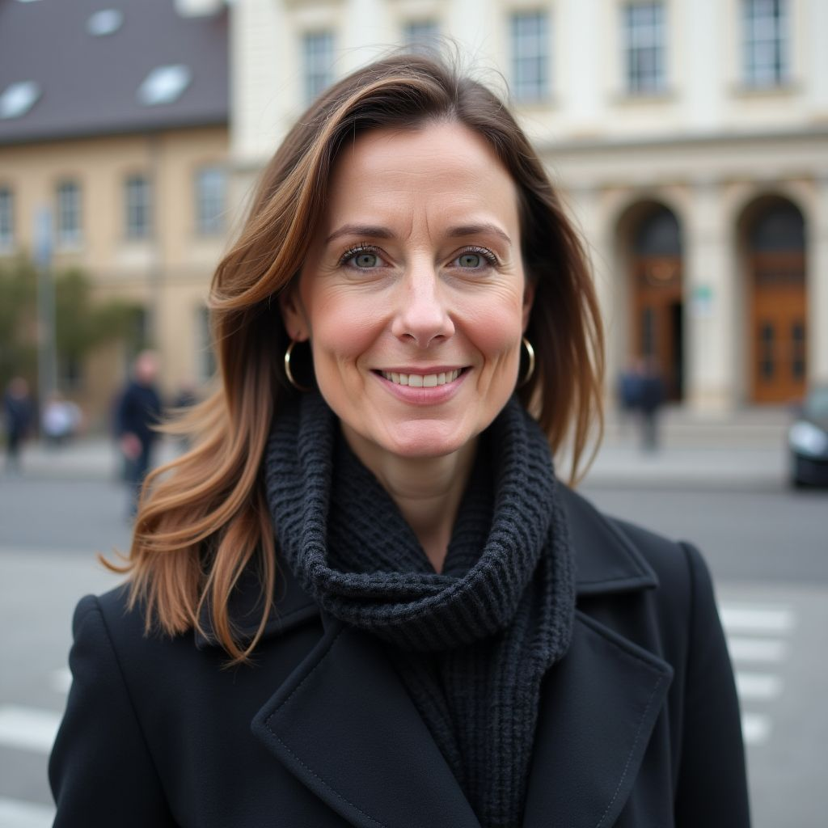  Who am I? I am Susan Perkins, the mayor of a coastal city that is a popular destination for cruise ships. My job is to balance the economic benefits of tourism with the well-being of our community.  Arguments: Economic Growth: Cruise ship tourism brings significant revenue to local businesses and increases job opportunities. (Source: Economic Development Quarterly, 'Economic Impact of Tourism') Infrastructure Strain: The influx of tourists can strain local infrastructure, requiring investment in public services and facilities. (Source: Urban Studies, 'Tourism and Urban Infrastructure') Cultural Preservation: It is crucial to ensure that tourism does not erode local culture and traditions. (Source: Journal of Heritage Tourism, 'Balancing Tourism and Cultural Heritage') Additional References for Research: The World Bank, 'Tourism Economics' UNWTO, 'Sustainable Tourism'
Local Business Owner    Who am I? I am James Thompson, the owner of a local restaurant in a popular cruise ship destination. Cruise ship tourism plays a vital role in my business's success.  Arguments: Revenue Boost: Cruise ship passengers are a significant source of income for local businesses, including restaurants and shops. (Source: Tourism Management, 'Economic Impact of Cruise Ship Tourism') Job Creation: Increased tourism leads to higher demand for services, creating more job opportunities for residents. (Source: Journal of Tourism Economics, 'Employment Effects of Tourism') Seasonal Stability: Cruise ship tourism can provide a steady flow of customers during off-peak seasons. (Source: International Journal of Tourism Research, 'Seasonal Tourism Trends') Additional References for Research: Local Chamber of Commerce, 'Tourism Benefits' Cruise Lines International Association, 'Economic Impact' | Marine Biologist    Who am I? I am Dr. Kenji Yamamoto, a marine biologist studying the impact of cruise ship tourism on marine ecosystems. I work to understand and mitigate the negative effects on marine life.  Arguments: Ecosystem Damage: Cruise ships can damage coral reefs and marine ecosystems through anchoring and pollution. (Source: Marine Pollution Bulletin, 'Impact of Cruise Ships on Coral Reefs') Invasive Species: Ballast water from cruise ships can introduce invasive species to new environments, disrupting local ecosystems. (Source: Environmental Science & Technology, 'Invasive Species in Ballast Water') Conservation Efforts: Promoting sustainable tourism practices can help protect marine biodiversity. (Source: Journal of Environmental Management, 'Sustainable Tourism and Marine Conservation') Additional References for Research: National Oceanic and Atmospheric Administration (NOAA), 'Marine Ecosystems' WWF, 'Marine Conservation'
Cruise Ship Company Representative  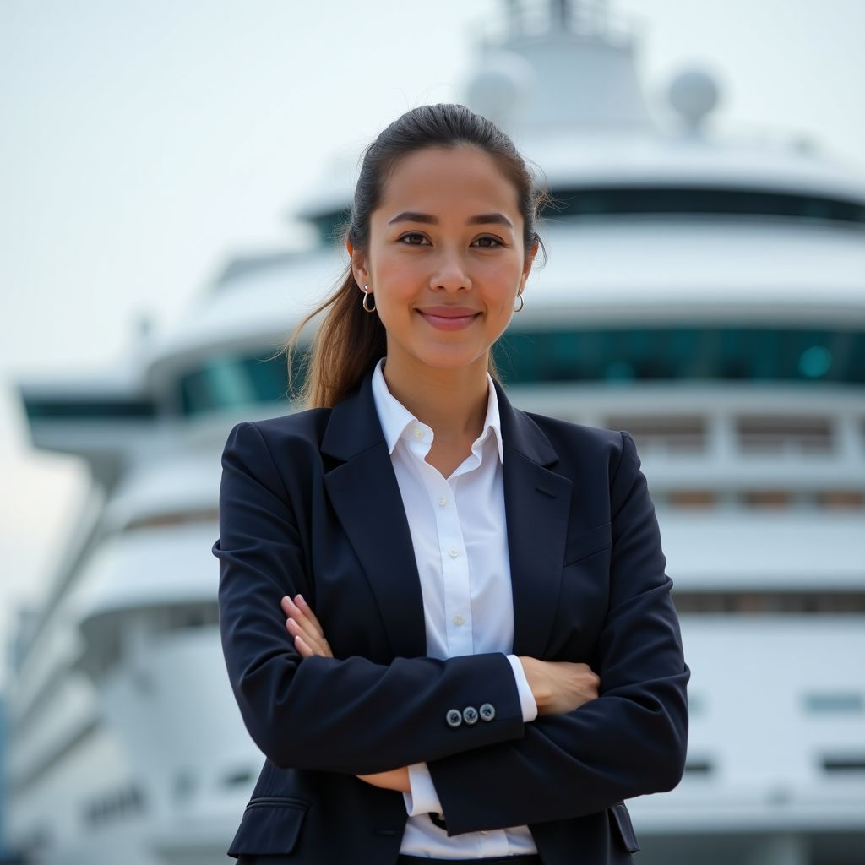  Who am I? I am Carla Rodriguez, a representative for a major cruise ship company. My role is to advocate for the benefits of cruise ship tourism and address concerns about environmental impact.  Arguments: Economic Contribution: Cruise ship tourism significantly contributes to the global economy, supporting millions of jobs. (Source: Cruise Lines International Association, 'Global Economic Impact') Sustainable Practices: Many cruise companies are adopting sustainable practices to minimize their environmental footprint. (Source: Journal of Sustainable Tourism, 'Green Practices in Cruise Tourism') Community Partnerships: Cruise companies often engage in partnerships with local communities to support development and conservation efforts. (Source: Tourism Management, 'Corporate Social Responsibility in Cruise Tourism') Additional References for Research: International Maritime Organization, 'Sustainable Shipping' World Travel & Tourism Council, 'Economic Impact' | Consumer Advocate  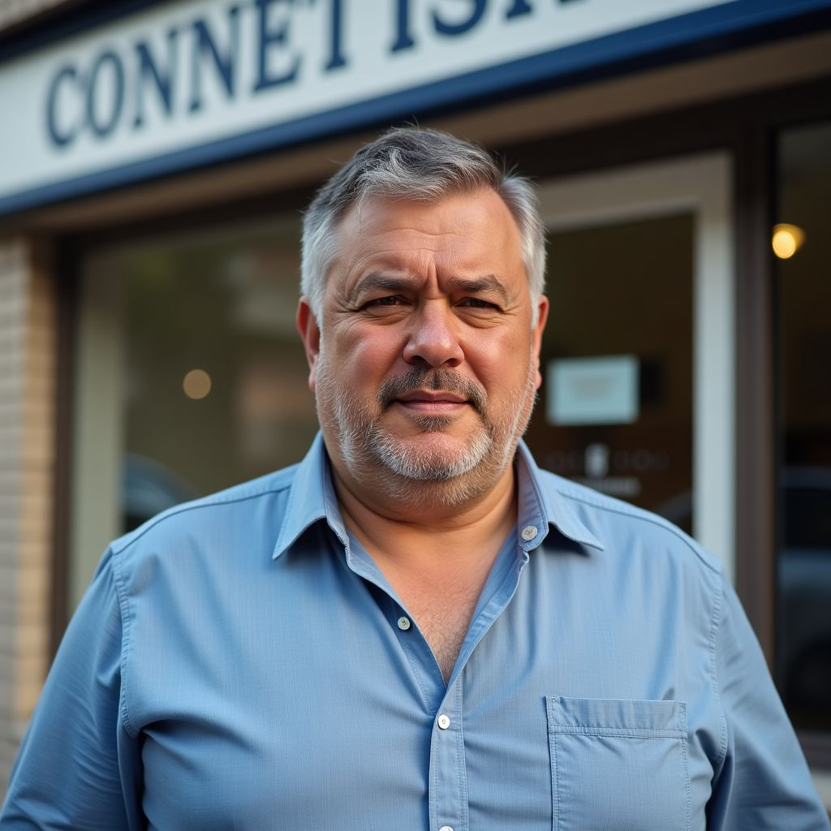  Who am I? I am Alejandro Martinez, a consumer advocate focused on ensuring fair practices in the tourism industry. My goal is to protect consumer rights and promote responsible tourism.  Arguments: Transparency: Cruise companies need to provide transparent information about their environmental practices and impacts. (Source: Consumer Reports, 'Transparency in the Tourism Industry') Fair Pricing: Ensuring that consumers are not overcharged and receive value for their money is essential. (Source: Journal of Consumer Affairs, 'Fair Pricing in Tourism') Ethical Treatment: Advocating for the ethical treatment of workers and local communities affected by cruise tourism. (Source: Business Ethics Quarterly, 'Ethics in Tourism') Additional References for Research: Consumer Federation of America, 'Consumer Rights' Fair Trade Tourism, 'Ethical Tourism'
Moderator

Who am I? I am Priya Sharma, the moderator for today's talk show on cruise ship tourism. My job is to facilitate the discussion and ensure all perspectives are heard.
Questions for All Experts: What are the main benefits and drawbacks of cruise ship tourism? How can we balance economic benefits with environmental protection? What are the most effective sustainable practices currently being implemented in the cruise industry? Specific Questions: Environmental Activist: Can you elaborate on the specific types of pollution caused by cruise ships? Local Politician: How does your city manage the influx of tourists during peak season? Local Business Owner: How has cruise ship tourism affected your business's growth? Marine Biologist: What are the most critical marine species affected by cruise ship tourism? Cruise Ship Company Representative: What initiatives are your company taking to reduce environmental impact? Consumer Advocate: How can consumers ensure they are supporting responsible tourism practices?

