Diary entry
Dear Diary,

Today was a whirlwind of adventures and emotions. As I soared above the city, the wind lifting my spirit, I felt a deep connection to the world below. My name is Diana, and I come from the mystical island of Themyscira. As an Amazon, I possess immense strength, speed, and the ability to fly. My golden Lasso of Truth helps me uncover honesty in the most challenging situations.

I excel in combat, thanks to years of training with my Amazon sisters. Whether it's battling fierce creatures or stopping a runaway train, my skills are always put to the test. But fitting into the modern world can be tricky. Sometimes, I struggle with understanding human customs and technology. The complexities of everyday life can be more daunting than fighting mythical beasts.

The most thrilling moment today was rescuing a group of children from a collapsing building. Using my strength, I supported the structure long enough for everyone to escape safely. Their smiles and gratitude were the best rewards. Even though I face formidable foes like Ares and Cheetah, it's these small acts of heroism that truly make my journey worthwhile.

Until next time,
Your dedicated heroine

Read the text and answer the questions to get to know the superhero/superheroine.
What is their superhero name?
___________________________________________________________________
What are typical characteristics?
___________________________________________________________________
What is she particularly good at?
___________________________________________________________________
What is she not good at?
___________________________________________________________________
What are exciting moments that the hero/heroine talks of?
___________________________________________________________________

And now you!
Which hero/heroine fascinates you the most? Fill out the profile and present your hero/heroine to your class.
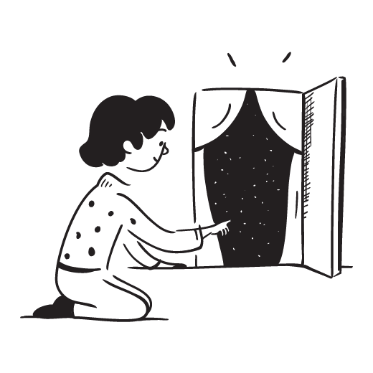 | Name
 | Typical characteristics
 | This is what I like about him/her
What is he/she particularly good at?

What is he/she not good at?

This is what I would like to know about him/her

I have experienced these adventures with him/her

Write a fantasy story!
What kind of adventure would you experience if you were him/her? What would you like to do? What would you be afraid of?

___________________________________________________________________

___________________________________________________________________

___________________________________________________________________

___________________________________________________________________

