|  |
| --- |
| Welcome, brave time traveller! Your time machine is stuck in a time loop and you are trapped in history. Returning to the present seems unattainable. Only by solving all the puzzles can you restart the machine and return home safely. Use your wits, gather information, and solve every challenge. Time is running out - are you ready to uncover the secrets of the past and continue your journey?    Good luck, your future depends on it! |



|  |
| --- |
| Get started, collect information and solve the first puzzle! The first thing you need to do is get an overview of the place and time you have landed in. This knowledge can help you with further puzzles. Therefore, read the following text |

### The First World War: A Global Conflict

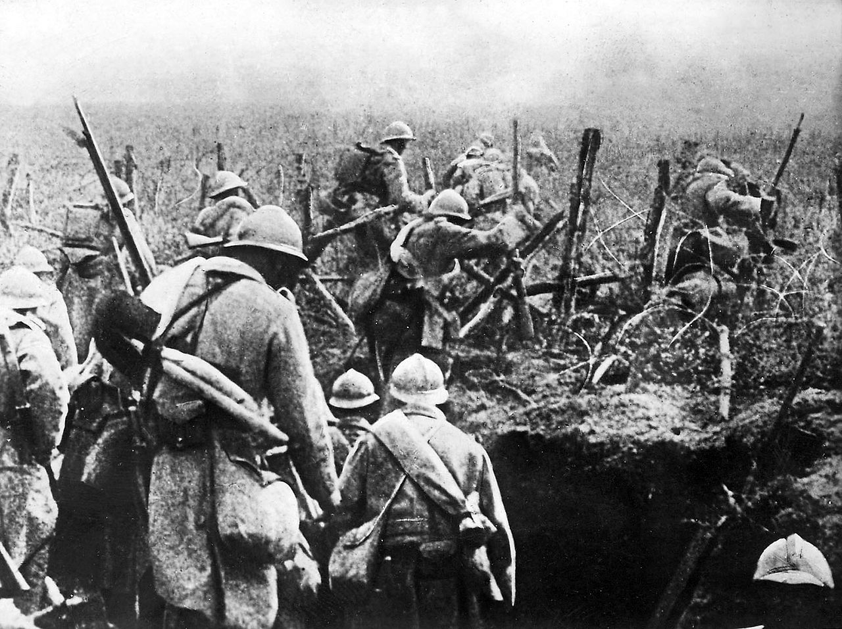

Source: Wikipedia

The First World War, also known as World War I, was a global conflict that lasted from 1914 to 1918. It involved many of the world's great powers, which were divided into two main alliances: the Allied Powers and the Central Powers. The war began after the assassination of Archduke Franz Ferdinand of Austria and quickly escalated into a full-scale conflict.

The war was fought on several fronts, including Europe, the Middle East, Africa, and the Pacific. Trench warfare became a common feature of the Western Front, where soldiers lived and fought in trenches for months on end. New technologies such as machine guns, tanks, and chemical weapons made the war particularly deadly.

Major battles like the Battle of Verdun and the Battle of the Somme resulted in massive casualties. The war also saw significant involvement from colonial troops from Africa, Asia, and the Americas, highlighting its global nature.

The war ended on November 11, 1918, with the signing of the Armistice. The Treaty of Versailles, signed in 1919, officially ended the state of war between Germany and the Allied Powers. The war had profound effects on the world, leading to significant political changes and setting the stage for World War II.

### ⌛ Select the correct answer.

###### **World War I starts in 1914 and ends in 1918.**

True False

###### **The assassination of Archduke Franz Ferdinand of Austria triggers the start of World War I.**

True False

###### **The Central Powers in World War I include France, Britain, and Russia.**

True False

###### **New weapons used during World War I include tanks, machine guns, and poison gas.**

True False

###### **The war ends with the signing of the Treaty of Paris in 1919.**

True False

###### **The aftermath of World War I leads to significant political changes.**

True False

###### **Many women take on new roles, working in factories and serving as nurses during World War I.**

True False

|  |
| --- |
| Great! Let's move on to the next puzzle. You will find two audio messages from people who can tell you more about the time. Listen to the recordings and then answer the questions. |

|  |  |
| --- | --- |
|  | Audio Content  To listen to audio content just scan the QR code and listen to it on the digital worksheet.  https://to-teach.ai/worksheet/FJWJwD3lIJdipiUnRP2h |

|  |  |
| --- | --- |
|  | Audio Content  To listen to audio content just scan the QR code and listen to it on the digital worksheet.  https://to-teach.ai/worksheet/FJWJwD3lIJdipiUnRP2h |

Describe the roles and responsibilities of Alvin York during the Great War as mentioned in the text.

___________________________________________________________________

___________________________________________________________________

___________________________________________________________________

Explain the challenges Flora Sandes faces as a female soldier in the Serbian Army and how she overcomes them.

___________________________________________________________________

___________________________________________________________________

___________________________________________________________________

|  |
| --- |
| Almost there! Solve the following task and find all the words. |

|  |  |  |  |  |  |  |  |  |  |  |  |  |  |  |  |  |
| --- | --- | --- | --- | --- | --- | --- | --- | --- | --- | --- | --- | --- | --- | --- | --- | --- |
| P | S | W | K | S | O | N | B | K | Q | X | L | H | W | A | B | Q |
| I | U | O | F | Y | Q | B | Z | S | Z | U | E | T | H | M | O | X |
| A | O | R | E | X | I | T | B | R | K | L | T | I | U | K | C | W |
| S | O | L | D | I | E | R | S | D | I | A | L | C | U | P | O | G |
| X | F | D | T | W | D | E | T | K | K | L | M | M | Q | H | U | E |
| H | J | W | G | C | E | N | T | R | A | L | P | O | W | E | R | S |
| U | D | A | K | X | D | C | U | O | Q | I | J | L | F | B | A | W |
| C | Y | R | E | D | A | H | T | T | R | E | A | T | Y | Z | G | Z |
| X | A | I | E | T | E | E | T | N | W | S | Z | D | B | T | E | M |
| W | X | I | Y | K | V | S | B | N | P | B | U | F | K | I | R | B |

WORLDWARI

SOLDIERS

TRENCHES

ALLIES

CENTRALPOWERS

TREATY

COURAGE

|  |
| --- |
| You've almost made it! One last puzzle. |

|  |  |  |  |  |  |  |  |  |  |  |  |  |  |  |
| --- | --- | --- | --- | --- | --- | --- | --- | --- | --- | --- | --- | --- | --- | --- |
|  |  |  |  |  | 3 |  |  |  | 5 |  |  |  |  |  |
|  | 1 |  |  |  |  |  |  |  |  |  |  | 4 |  |  |
|  |  |  |  |  |  |  |  |  |  |  |  |  |  |  |
| 2 |  |  |  |  |  |  |  |  |  |  |  |  |  |  |
|  |  |  |  |  |  |  |  |  |  |  |  |  |  |  |
|  |  |  |  |  |  |  |  |  |  |  |  |  |  |  |
|  |  |  |  |  |  |  |  | 6 |  |  |  |  |  |  |
|  |  |  |  |  |  |  |  |  |  |  |  |  |  |  |
|  |  |  |  |  |  |  |  |  |  |  |  |  |  |  |
|  |  |  |  |  |  |  |  |  |  |  |  |  |  |  |
|  |  |  |  |  |  |  |  |  |  |  |  |  |  |  |

Across

1 French soldiers fought in this famous 1916 battle. (6)

2 Sergeant Alvin York worked as this before the war. (10)

6 Flora Sandes fights alongside this army. (7)

Down

3 Flora Sandes initially worked as this before becoming a soldier. (5)

4 The treaty that ended World War I was signed here. (10)

5 German military force that Alvin York was tasked to silence. (7)

|  |
| --- |
| You've done it! You enter the last letters into the machine and it works! Now it's time to buckle up and start your journey into the present. You've done a great job! |