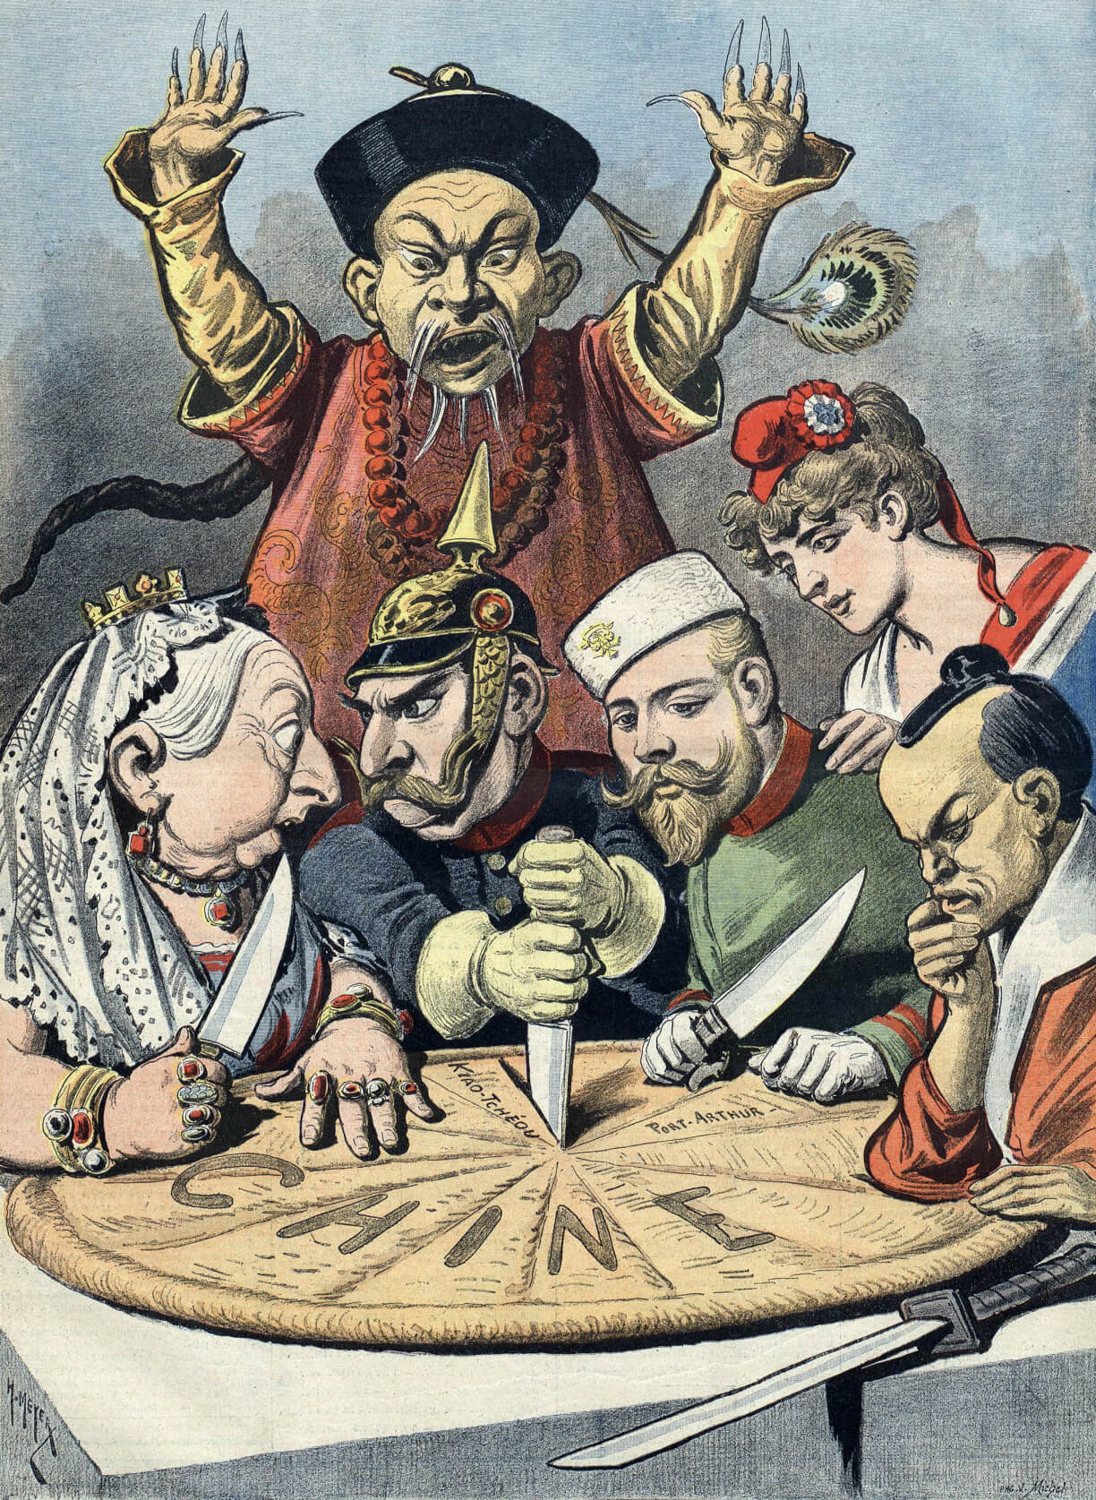

"En Chine Le gâteau des Rois et... des Empereurs" - Henri Meyer - "Le petit journal" - 16.01.1898

### Choose the correct answer

###### **The main topic of the cartoon is the division of China's land and resources by foreign powers.**

True False

###### **The cartoon was published in 'Le petit journal' on January 16, 1898.**

True False

###### **Henri Meyer created this cartoon for 'Le petit journal'.**

True False

###### **The cartoon shows various national powers represented by figures in different attire and insignia.**

True False

###### **The pie in the cartoon is labeled 'Chine', which means China in French.**

True False

###### **One of the figures representing national powers is wearing a distinctive German military helmet called a Pickelhaube.**

True False

###### **The figure representing China in the cartoon is wearing a crown.**

True False

###### **The place names written on the pie/map in the cartoon do not include 'Port Arthur'.**

True False

|  |
| --- |
| Analyzing political cartoons First, take a close look at the different parts of the cartoon. Notice the people, animals, objects, and other details you can see. Pay attention to the facial expressions and body language of the characters. Don't forget to include any text in the cartoon, like speech bubbles or captions.    Next, it's time to understand the cartoon in its historical context. Gather extra information like the title of the cartoon, the name of the artist, where and when it was created and published, and what the cartoon is about. |

Describe the attire and insignia of the figures surrounding the pie in the cartoon. What do they signify?

___________________________________________________________________

___________________________________________________________________

___________________________________________________________________

Explain the significance of the Chinese figure's expression and position in the cartoon.

___________________________________________________________________

___________________________________________________________________

___________________________________________________________________