Info
This worksheet contains information on the life of a famous historical figure. Use the information in the text to complete the profile.

Albert Einstein

Albert Einstein was a famous scientist who was born in Germany in 1879. He worked on theoretical physics and developed the theory of relativity. He was awarded the Nobel Prize in Physics in 1921 for his work. His famous equation is E=mc², which means energy equals mass times the speed of light squared.

In 1933, Einstein moved to the United States because of Adolf Hitler and the Nazis coming to power in Germany. He sent a letter to President Franklin D. Roosevelt about Germany making a nuclear weapon, which led to the Manhattan Project and the U.S. creating the atomic bomb.

Einstein was married twice and had three children. He was very interested in his Judaism and was politically active for socialism and Zionism. He was offered the presidency of Israel in 1952 but turned it down.

Einstein also discovered the photoelectric effect, which explains why high frequency light such as UV can cause electrons to be emitted from a metal surface, but lower frequency light such as red or infrared cannot. He was awarded the Nobel Prize for this discovery in 1921.

My Notes

___________________________________________________________________

___________________________________________________________________

___________________________________________________________________

___________________________________________________________________

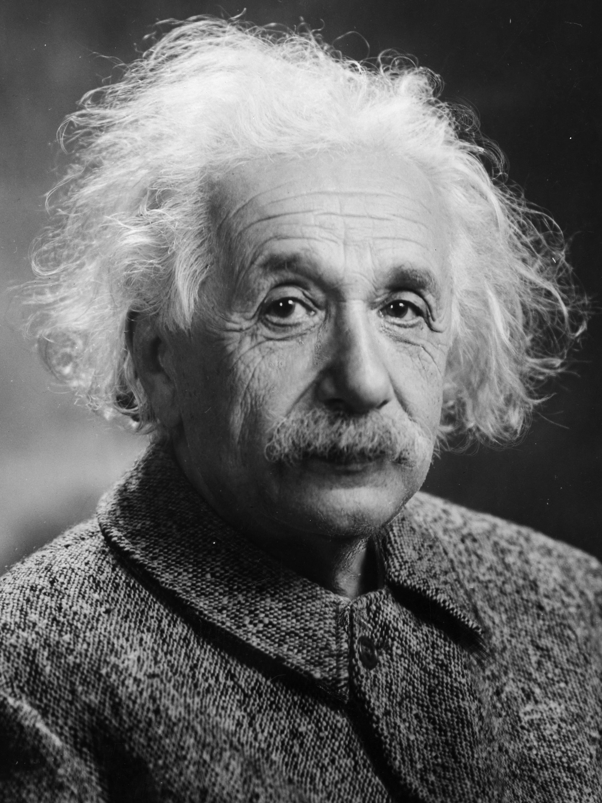 | Name
 | Birth date
 | Birthplace
Life

Work

Achievement

Famous for

📋 Select the correct answer from the options provided.

What is Albert Einstein famous for?
Developing the theory of relativity Inventing the telephone Writing novels Painting famous artworks

Why did Albert Einstein move to the United States in 1933?
Because of Adolf Hitler and the Nazis coming to power in Germany To study at a university To find a new job To visit family

What was Einstein's famous equation?
E=mc² F=ma a²+b²=c² E=hf

What prize did Albert Einstein win in 1921?
The Nobel Prize in Physics The Olympic Gold Medal The Pulitzer Prize The Grammy Award

