|  |
| --- |
| The Yellow Kid "The Yellow Kid" is an important comic strip from the late 19th century, often considered the first true comic strip in American newspapers. Created by Richard F. Outcault, it was first published in 1895 in the New York World newspaper. The comic featured a bald, snaggle-toothed boy wearing a bright yellow nightshirt, known as the Yellow Kid. The setting was a poor neighborhood, and the strips humorously depicted the everyday life of the Kid and his friends.    The Yellow Kid became famous for its unique style and use of speech balloons, which were a new and innovative way to show dialogue in comics. This comic strip played a key role in the rise of "yellow journalism," a term used to describe sensationalized news stories. The Yellow Kid was so popular that it appeared in different products, from toys to advertising, making it one of the first comic characters to achieve mass merchandising success. Today, it is remembered as a pioneer in the comic strip world, influencing the development of modern comics.      Task:  Look at the following image from "The Yellow Kid". Does this remind you of comic strips nowadays? What is the same, what is different? |

|  |
| --- |
| Well hully gee here's to you The phrase "well hully gee here's to you" from "The Yellow Kid" comic strip captures the playful and whimsical nature of the character, Mickey Dugan, known as the Yellow Kid. This expression reflects the slang and informal language used humorously in the comic, contributing to its appeal to readers in the late 19th century. The Yellow Kid's use of such phrases helped establish a unique voice for the character and contributed to the comic strip's role in shaping early American popular culture. |

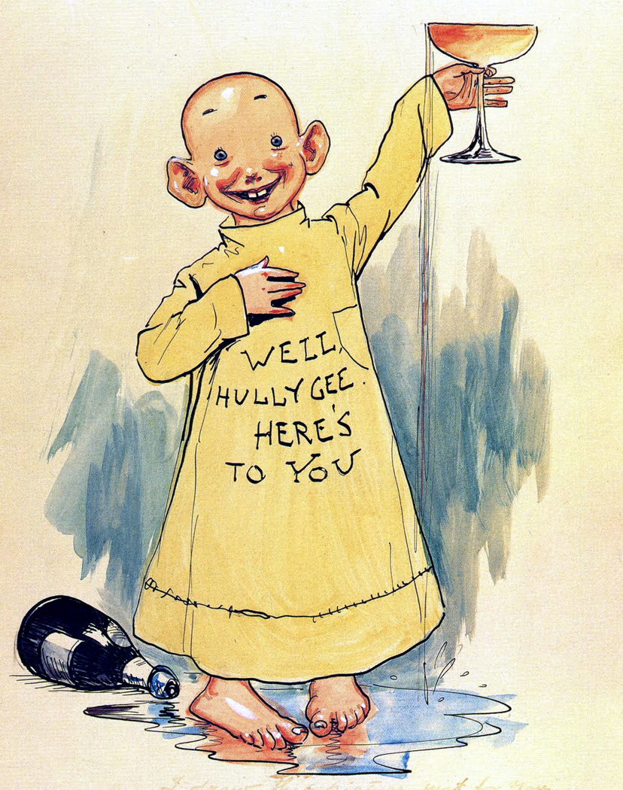

Richard Felton Outcault - http://en.wikipedia.org/wiki/Image:YellowKid.jpeg Cropped, sized; original from http://www.toonopedia.com/yellow.htm (Yellow Kid is public domain circa 1897)

|  |
| --- |
| Task Read the following text about the origin of picture stories. Then answer the questions. |

|  |
| --- |
| Origin of picture stories Picture stories, often known as comics or graphic novels, have a fascinating history and origin. They combine visuals and text to tell a story, making them an engaging form of storytelling.  The origin of picture stories can be traced back to ancient times. Egyptian hieroglyphs, which used pictures to convey messages, are among the earliest examples. In the Middle Ages, narrative art, like the Bayeux Tapestry, depicted historical events through sequential images.  However, the modern comic book format began to take shape in the late 19th and early 20th centuries. In the 1890s, newspaper comic strips like "The Yellow Kid" gained popularity in the United States. These early comics used humor and simple illustrations to entertain readers. By the 1930s, comic books became widely available, with superheroes like Superman capturing the imagination of young readers.  The meaning of picture stories lies in their ability to convey complex narratives through a blend of visual art and text. They can tackle a wide range of themes, from action and adventure to social issues and personal experiences. Picture stories also encourage creativity and imagination, allowing readers to interpret the visuals and connect them with the dialogue.  Today, picture stories are a global phenomenon, appealing to audiences of all ages and backgrounds, and continue to evolve as a powerful storytelling medium. |

### Select the correct answer from the options provided.

###### **What is one of the earliest examples of picture stories?**

The Bayeux Tapestry Egyptian hieroglyphs Japanese manga The Yellow Kid comic strip

###### **How did picture stories in the form of comic strips first gain popularity in the United States?**

Through graphic novels Through superhero films Through radio dramas Through newspaper comic strips

###### **What role do visuals play in picture stories?**

They are used only for humor They replace the need for text They solely provide entertainment They enhance the narrative by conveying complex stories

###### **In what era did the modern comic book format begin to shape?**

Mid 20th century During the Renaissance Early 16th century Late 19th and early 20th centuries

###### **What themes can picture stories tackle?**

Only humor and action Only fantasy and science fiction Only historical events A wide range of themes including social issues and personal experiences

|  |
| --- |
| Your first impression Look at the following picture story and discuss your ideas in small groups or with the entire class:    What is happening?  Is it a funny, interesting, sad, etc. story? |

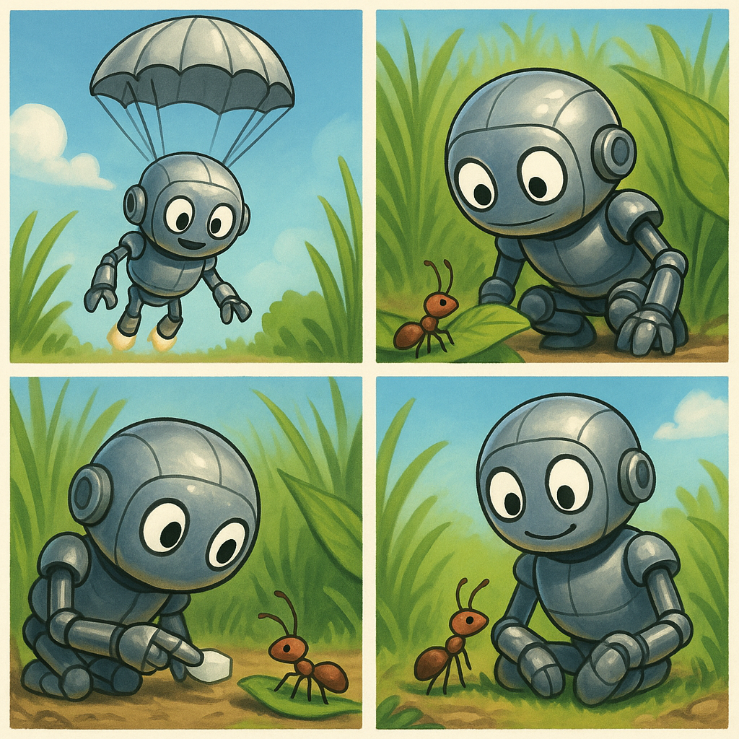

|  |
| --- |
| More detail Now look at the picture story in more detail and answer the questions. |

### Select the correct answer from the options provided.

###### **What is the main setting of the first panel in the comic strip?**

A busy city street A lush, green field A dark forest An underwater scene

###### **How does the Robot show its interest in the Ant?**

By offering a sugar cube By ignoring the Ant By taking the Ant away By stepping on the leaf

###### **What action signifies the friendship between the Robot and the Ant?**

The Robot sits contently with the Ant on its knee The Robot leaves the Ant alone The Robot chases the Ant The Robot steps on the Ant

###### **Why might the Robot and the Ant be happy by the end of the comic strip?**

They have formed a friendship They are going on an adventure They are preparing to leave the field They have found treasure

Name something that signifies the beginning of a friendship in the story.

___________________________________________________________________

___________________________________________________________________

___________________________________________________________________

Describe the setting where the Robot and the Ant first meet.

___________________________________________________________________

___________________________________________________________________

___________________________________________________________________

Explain how the Robot's actions contribute to the theme of friendship in the story.

___________________________________________________________________

___________________________________________________________________

___________________________________________________________________

|  |
| --- |
| Your own picture story Now it's your turn! Come up with your own idea for a picture story. The following guideline will help you. |

|  |
| --- |
| Guidelines for your own picture story Step 1: Setting the Scene    Start by establishing the setting for your story. Choose a location that creates a specific mood or atmosphere, like a dimly lit alley for mystery. Use colors and lighting to enhance the mood. Shadows and light sources, such as streetlamps, can add depth and intrigue to your setting.    Step 2: Introducing the Character    Introduce a central character who will drive the story. Choose an interesting figure, like a raccoon, and add unique features such as oversized goggles to give it personality. Think about how the character’s appearance and expression can hint at its intentions and emotions.    Step 3: Building Curiosity  Develop the story by showing the character becoming more engaged with its surroundings. Use body language to convey emotions and intentions. For example, if the raccoon climbs onto the trash can, it signals anticipation and readiness to explore. This progression keeps the audience interested.  Step 4: Presenting Challenges  In the next panel, introduce a challenge or conflict. For instance, uncovering a set of tools suggests a problem-solving angle. This step is crucial as it transforms curiosity into action and adds depth to the story. Ensure the character’s response shows resourcefulness and creativity.  Step 5: Achieving Resolution  Conclude the story with a resolution. Show the character achieving its goal, like finding a treasure trove of food. This outcome should reflect the themes of the story, such as ingenuity and the joy of small victories. Use expressions and visual elements to convey delight and satisfaction. |

Step 1: Setting the Scene

___________________________________________________________________

___________________________________________________________________

___________________________________________________________________

Step 2: Introducing the Character

___________________________________________________________________

___________________________________________________________________

___________________________________________________________________

Step 3: Building Curiosity

___________________________________________________________________

___________________________________________________________________

___________________________________________________________________

Step 4: Presenting Challenges

___________________________________________________________________

___________________________________________________________________

___________________________________________________________________

Step 5: Achieving Resolution

___________________________________________________________________

___________________________________________________________________

___________________________________________________________________

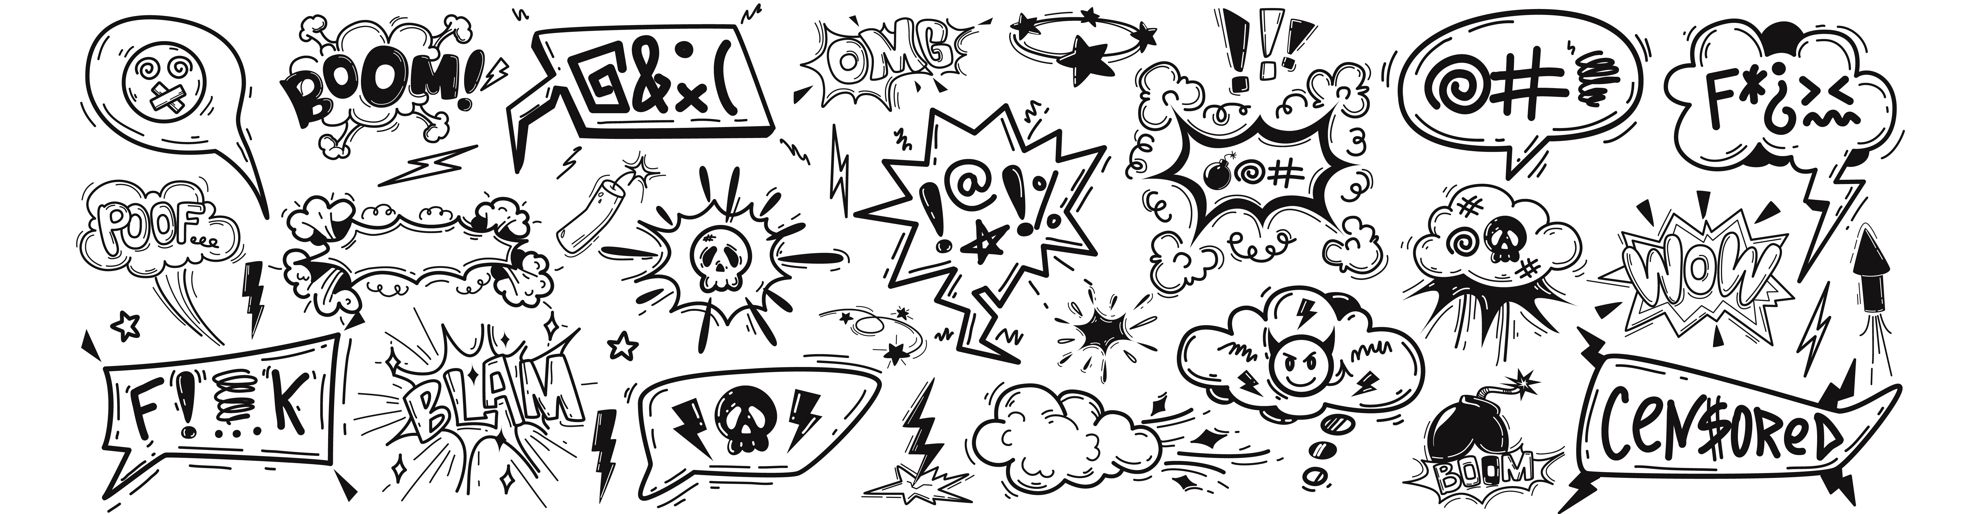

|  |
| --- |
| Present your picture story Show everyone what you created! Show your picture story to the rest of the class. When presenting your picture story, tell the others    how you came up with the idea  what you want to express with your picture story  what the biggest challenges were when creating the picture story. |